MOHAMMAD ISHFAQ

PERMANENT ADDRESS:

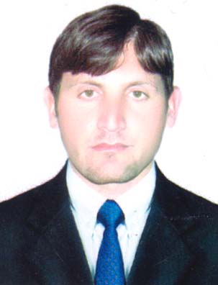
Village and P.O. Takkar
Dist. Mardan & Tehsil Takht bhai kpk
Cell No: 0333-9667774/ 0314-5445664

Email: Ishfaq.chef@gmail.com

OBJECTIVE

Can work in a competitive in challenging environment by using my knowledge and capabilities to achieve devised goals in an effective way and also looking for an organization where I can improve my standard of my life.

PERSONAL INFORMATION

Father Name : M. Karim
Date of birth : 05-03-1989
Nationality : Pakistani
CNIC No : 17101-7877464-9
Marital Status : Married
Religion : Islam
Domicile : Charsadda KPK

QUALIFICATION

Examination : Board/University

S.S.C : BISE Peshawar
F.sc : BISE Peshawar
B.com : Peshawar University

PROFESSIONAL ACHIEVEMENTS
- One Year DIT Diploma from Soft Tech. Institute Mardan KPK.
- Two year Medical Technician Diploma from Tariq G Peshawar.

SKILLS
- Ms-window
- Ms-Office
- Data Base Management
- Hardware
- Internet
- Typing
- Excellent communication and presentation skill.

LANGUAGES
- Urdu
- English
- Pashto
EXPERIENCE
- Two Year experience as a “Computer Operator in Indus Marble (Pvt) Ltd. Peshawar.
- 2 Years experience as Data enumerator. in CHEF NGO.
- 7 Years experience as a Computer Operator in WHO.
- 1 Year in CUP NGO as a Data collector.
- 6 month as a enumerator and data collection in German project with KMU
TRAINING & WORKSHOP:

- Impairment (causes, prevention, rehabilitation and Habilitation as well as detection) according to their need in daily work in (PC Hotel Peshawar).
- Mental Health Disorders Identification training for health personal`s & community health workers by CHEF INT. (PC Hotel Peshawar).
- Disability and the Right of the People with Disability provided by CHEF International, in ( Shelton GreenPeshawar).
- Early Detection and Intervention for Health Personal`s & community Health workers provided by CHEF Int. in (PC Hotel Peshawar).
- Workshop on "Active Citizens`” Programmed provided by Special Life Foundation (SLF) {British Council}.
- Monitoring and Supervision and Data analysis in W.H.O.
- Workshops on Hygiene and Health in CUP (NGO).
- Worked as a Monitor with KMU (German Project) on Health.

