**URRICULUM ITAE**

***v***

***c***

|  |
| --- |
| **Muhammad Adil** |

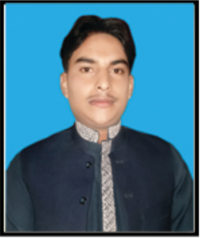

Postal Address**: House No. 14 Behari Colony Serai Nuarang**

**District Lakki Marwar KPK**.

*Contact No: 0315-5065766 , 0304-0572778 , 0304-0577352*

*Email:- adilirfan122@gmail.com*

|  |
| --- |
| ***Objective*** |

*To join a* ***REPUTABLE*** *organization that* ***values******HARD WORK*** *and* ***DEDICATION****.*

|  |
| --- |
| ***Personal Profile*** |

*Father’s Name : Wakil Ahmad*

*Date of Birth : 21.05.1993*

*Religion : Muslim*

*Gender : Male*

*Marital Status : Single*

*Nationality : Pakistani*

*N.I.C No. : 11201-5607434-5*

*Domicile : Lakki Marwat (KPK)*

|  |  |  |  |  |  |
| --- | --- | --- | --- | --- | --- |
| ***Academic Qualification*** | | | | | |
| **QUALIFICATION** | | **Session** | **Marks Obtd** | **Division** | **INSTITUTE** |
| S.S.C | | 2009 | 659/1050 | 1ST | BISE Bannu |
| F.Sc | | 2011 | 572/1100 | 2nd | BISE Bannu |
| B.A | | 2014 | 267/550 | 2nd | UST, Bannu |
| M.A (Islamiayat) | | 2016 | 515/1100 | 2nd | UST, Bannu |
| DIT | | 2017 | 1007/1400 | 1st | BTE Peshawar |
| **SKiILLS** | | | | | |
| 1. 06 Months Electrician course from GTVC Serai Naurang 2. 06 Months Computer course in Office Automation from Phoenix Computer Center Serai Naurang. | | | | | |
| ***Languages*** | |

* English
* Pashto
* Urdu

***Work Experience***

* 2 years working experience as TPSM in CTC (Polio Eradication) District Lakki Marwat.
* 2 years working experience as Office Assistant/care taker BFMC Serai Naurang.
* 2 year Experience as Lead TTM & TTM in WHO ( Polio Eradication) UC Pahar Khel & UC Serai Naurang District Lakki Marwat.
* Presently working as UCSP in WHO (Polio Eradication) UC Serai Naurang District Lakki marwat