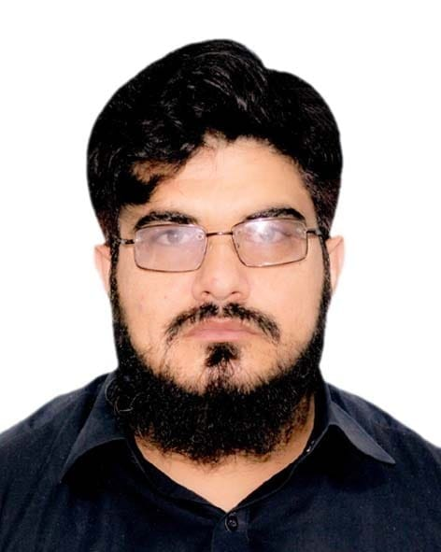 |  | dr. Muhammad asif
Profile  Compassionate and committed community doctor with 6 years of experience in providing comprehensive healthcare services in diverse community settings. Skilled in primary care, chronic disease management, and preventive health strategies, with a strong focus on patient-centered care. Proven ability to build trust with patients and collaborate with local health organizations to address community health needs. Dedicated to improving health outcomes through education, outreach, and personalized care for underserved populations  Contact  PHONE:  0333-9097956  ADDRESS:  Post office Wana , South Waziristan.  EMAIL:  drshanwazir@gmail.com  Hobbies  cricket  football  current affairs |  | EDUCATION  SAIDU MEDICAL COLLEGE, KHYBER MEDICAL UNIVERSITY  MBBS  2012 - 2017  CADET COLLEGE RAZMAK  F.Sc  2009 – 201  WORK EXPERIENCE  GENERAL PHYSICIAN-PRIVATE PRACTICE- WANA SWTD  2018–Till now  SAIDU GROUP OF TEACHING HOSPITALS SWAT- HOUSE OFFICER  2017–2018  SKILLS  PRESENTATION  COMMUNICATION  MS OFFICE AND INTERNET

