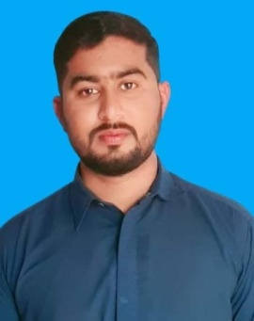
Curriculum Vitae

MUHAMMAD BILAL
Mailing Address: Mohalla behlol khelTehsil Kulachi Dist: Dera Ismail Khan
Mobile No : 0343-7872264

OBJECTIVE AND AMBITIONS:
- I want to achieve a respectable professional position in the society and in my own region through knowledge, hard work, efficiency, skills and service.

PERSONAL INFORMATION:
- Father’s Name : HAFIZ ABDUL WAHAB
- Date of Birth : 12/02/1996
- C.N.I.C # : 12102-1656717-3
- Domicile : D.I.Khan (KPK)
- Nationality : Pakistani
- Religion : Islam
- Marital Status : Single
- Gender : Male
ACADEMIC QUALIFICATION:

 | CERTIFICATE | Marks | YEAR OF PASSING | BOARD /UNIVERSITY
S.S.C |  | 631/1050 | 2012 | B.I.S.E-D.I.Khan
DAE (Civil) |  | 2152/3350 | 2015 | K.P.B.T.E Peshawar
B.sc |  | 253/550 | 2018 | Gomal University D.I.Khan
MA ( islamaiyat) |  | 661/1100 | 2021 | Gomal University D.I.Khan
D.I.T |  | 1141/1400 | 2015 | TTB Peshawar

Experience:
- 03 Year Experience Of Composing Work In Self Shop.
SKILLS:
- MS Office , MS Excel , English Typing , Power Point, Urdu Inpage,
Hardware and Software.
- Very Good Knowledge of MS Office Work.
- Internet, Mailing and Net Browsing

PROFESSIONAL TRAINING:
- 02 Years Teaching In AL FALAH PUBLIC High School Kulachi
- 01 Year Teaching In Muslim Public High School Kulachi

HOBBIES:
- Newspaper Reading , Books reading, Writing and Communication Skills
- Cricket, Football,
- Travelling, poetry.

LANGUAGE:

- English
- Pashto
- Saraiki
- Urdu

