Resume 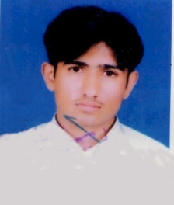

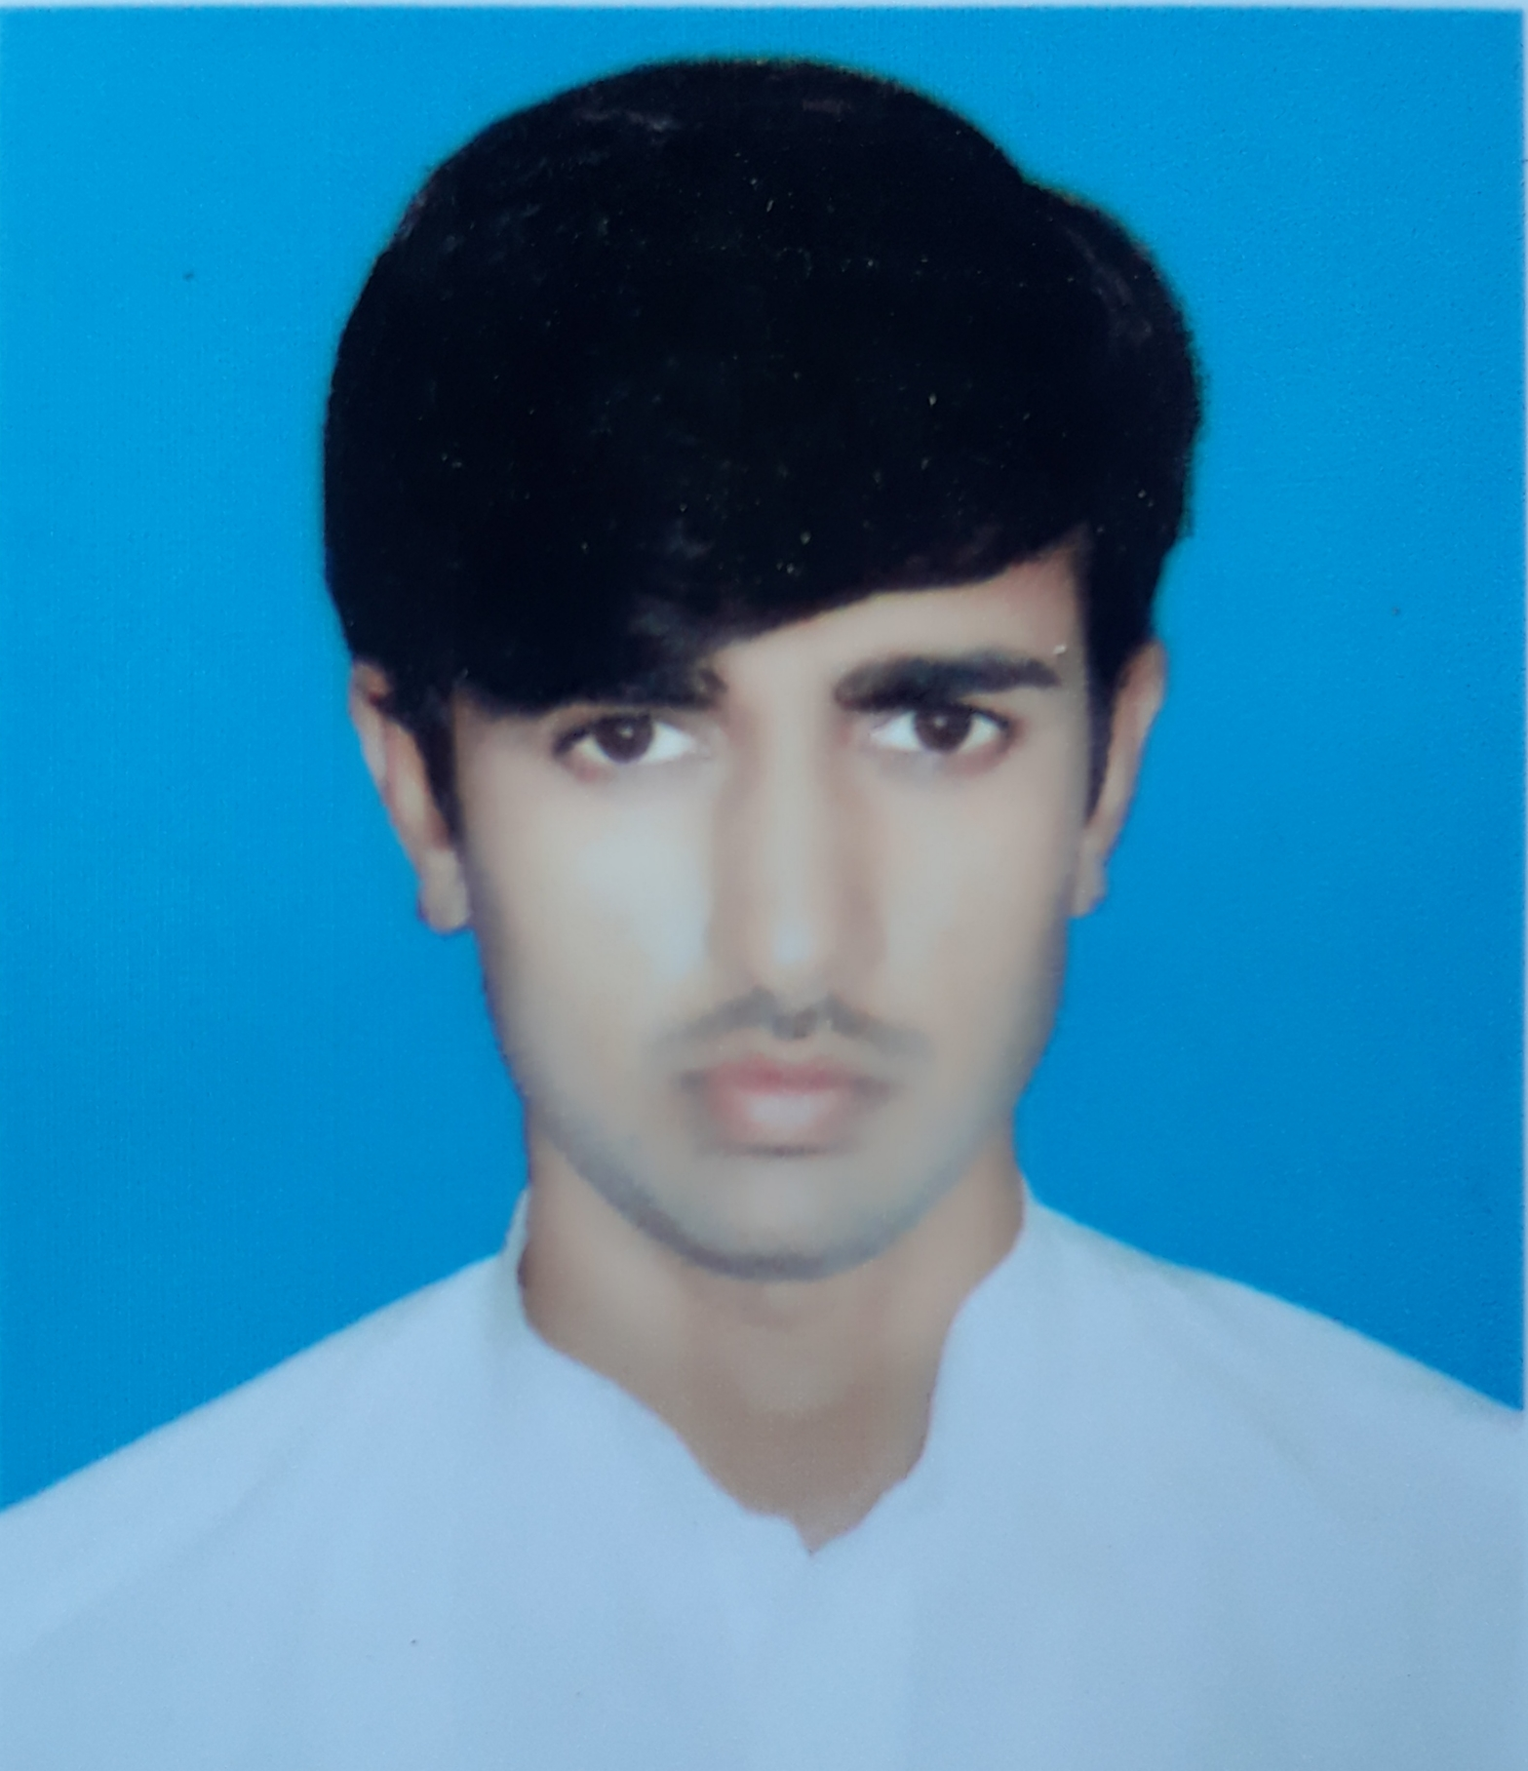
Muhammad Bilal Rasheed
Mailing Address:
Mohallah Mala Khel Tehsil Post Office Daraban Kalan Distt: D.I.Khan
Cell # 0345-9829638
Email: bilalrasheeddik@gmail.com

OBJECTIVE
To pursue a challenging career in a prestigious position having attractive working Environment, prospects of learning and growth, in-line with educational qualification, Skill, proficiency, experience and to utilize my capabilities to the fullest to improve and excel.

PERSONAL INFORMATION

- Father’s Name : Abdul Rasheed
- Date of Birth : 25 Nov 1993
- Domicile : D.I.Khan
- Nationality : Pakistani
- Religion : Islam
- Marital Status : Unmarried
- Permanent Address : Moh Malakhel Teh Daraban Kalan Dist D.I.KHAN
- N.I.C. No : 12104-1620585-9

ACADEMIC QUALIFICATION

QUALIFICATION | SUBJECT | PASSING YEAR | MARKS | BOARD / UNIVERSITY
S.S.C (science) | Computer | 2009 | 635/1050 | B.I.S.E D.I.khan
F.Sc | Computer | 2011 | 557/1100 | B.I.S.E D.I.Khan
B.A | English,Islamiat | 2016 | 276/550 | Gomal University D.I.Khan
M.A | Islamiat | 2019 | 667/1100 | Gomal University D.I.Khan
M.Sc | Pakistan Studies | 2020 | 1381/2000 | AIOU Islamabad

OTHER QULAFICATION:
DIPLOMA NAME | PASSING YEAR | MARKS | BOARD / UNIVERSITY
PTC | 2015 | 676/900 | AIOU Islamabad
D.I.T | 2016 | 1160/1400 | TTB Peshawar
CT | 2017 | 627/900 | AIOU Islamabad
B.Ed | Continue |  | AIOU Islamabad

Experience
- Three years teaching experience at OXFORD MODEL SCHOOL Daraban Kalan.
- Four years experience as Admin & Logistics Assistant in SABAWON Organization (NGO)
- Three months computer course from REHMAN COMPUTER ACADEMY Daraban Kalan
- Expertise in MS-Office, Photoshop, Internet and Office Administration.

LANGUAGE SKILLS

- English. Urdu. Saraiki. Pashto

