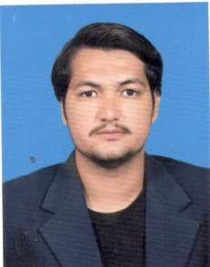MUHAMMAD HASSAN

ADDRESS: C-8/5 BALTISTANI MOHALLAH A.B.CINIA LINE KARACHI

MOBILE NO: 0305-8318002, 0345-3198026

EMAIL: muhdhassan161@gmail.com

OBJECTIVE:

I am a self-motivated, creative, and confident individual and a team player seeking a position in a leading organization that offers a professional working environment and opportunities for growth while achieving corporate goals.

PERSONAL DATA:

Father Name : Muhammad Nazir

Date of Birth : 16-Jan-1989

N.I.C No : 42201-3916044-5

Religion : Islam

Marital status : Married

QUALIFICATIONS:

|  |  |  |  |  |
| --- | --- | --- | --- | --- |
| EDUCATION | BOARD | GROUP | GRADE | YEAR |
| B.Com | Sindh Board | Commerce | 2nd Division | 2010 |
| Intermediate | Karachi Board | Pre- Engineering | D | 2008 |
| Matric | Karachi Board | Science | C | 2005 |

EXPERIENCE:

* Served as District Monitor for 1 year and 4 months in the EPI Project by WHO.
* Worked for 5 years as a Data Support Officer (D.S.O.) and Union Council Communication Officer (U.C.C.O.) in the Polio Project by UNICEF.
* Worked as a Data Entry Operator (D.E.O.) in Micro Merger (Pvt.) Ltd. for 10 months.
* Managed customer relations as a Customer Support Executive (CSE) and Technical Support Executive (TSE) in IBEX Global.
* Worked for 1 year as a Lab-Technician and Phlebotomist in Husaini Blood Bank.
* Completed a 4-month Diploma in Call Centre Agent from Ensign Communication.

COMPUTER SKILLS:

* MS Office
* Graphics Design (Adobe Photo Shop)
* Window installation & Networking.

PERSONALITY PRIDE:

* Superior communication and interpersonal skills.
* Excellent time management skills.
* Dynamics individual with a quest for knowledge and growth.
* The professional attitude, dedicated, honest, hardworking, and punctual.

LANGUAGE:

* English, Urdu and Balti.

REFERENCE:

References available upon request