|  |  |  |  |  |
| --- | --- | --- | --- | --- |
| **Exam** | **Year** | **Marks Obtained** | **Division** | **University / Board** |
| SSc | 2017 | 864/1100 | 1st | BISE Bannu |
| F.Sc  Pre-Med | 2019 | 707/1100 | 1st | BISE Bannu |
| B.A  Islamiyat | 2023 | 318/550 | 2nd | ULM Lakki Marwat |
| DIT | 2019 | 1079/1400 | 1st | BTE Peshawar |
| Diploma  Health | 2023 | 805/1450 | 1st | FPMA KPK |

**CURRICULUM VITAE**

**PERSONAL STATEMENTS:**

To become an active members of a dynamic team of any organization accept challenges and further to improve my professional skills. I will not make the institution feel sorry for hiring me.

**References:**

To be furnished on demand.

**ADDITIONAL ACTIVITIES:**

Reading Books, Magazines

**LANGUAGES:**

**ACADEMIC PROFILE**

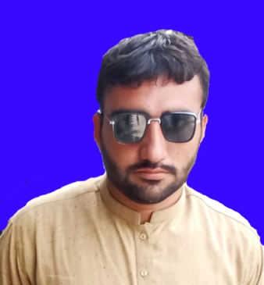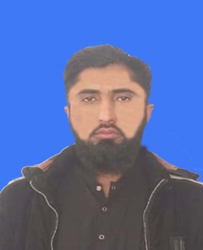

**Muhammad Idris**

**S/O**

**Ayub Khan**

**CNIC:22101-6767000-5**

**D.O.Birth: 12-12-2001**

**Nationality**: PAKISTAN

**Religion**: ISLAM

**Marital Status**: Single

**Domicile:** LAKKI MARWAT

**Contact #:**

0345-9771421

0320-9018156

**Gmail ID**.

Idreeskhan771421@gmail.com

**Residence & Mailing Address**:

Village Masti Khel P/O Tajoti Lakki Marwat Tehsil SD Bettani

|  |  |  |  |  |
| --- | --- | --- | --- | --- |
| **LANGUAGE** | **SPEAKING** | **LISTNING** | **READING** | **WRITING** |
| **ENGLISH** | **GOOD** | **GOOD** | **GOOD** | **GOOD** |
| **URDU** | **EXCELLENT** | **EXCELLENT** | **EXCELLENT** | **EXCELLENT** |
| **PASHTO** | **EXCELLENT** | **EXCELLENT** | **GOOD** | **GOOD** |