CURRICULUM VITAE

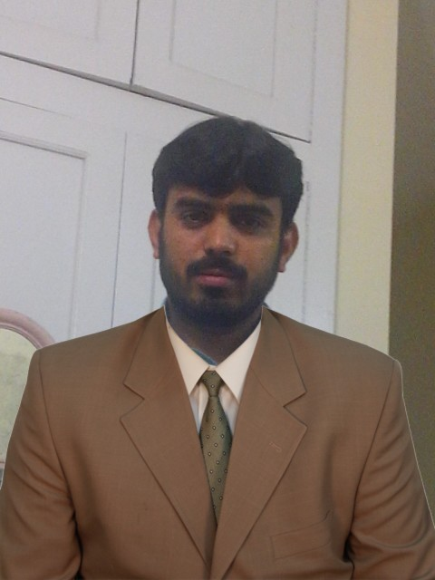
MUHAMMOD EJAZ
Village Kokar Sufaid Colony Near Chashma Road
Tehsil and District Dera Ismail Khan,
Khyber Pakhtunkhwa, Pakistan
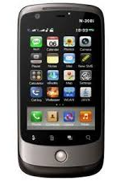
Cell: (0344-2574630)
E-mail: ejazmuhammad125@yahoo.com

Personal Information:

Father's Name : Muhammod Ali
Date of Birth : 02-03-1990
Nationality : Pakistani
NIC : 12103-1128624-3
Religion : Islam
Domicile : Dera Ismail khan
Marital Status : Married
Educational Qualification:

Year Total Marks Division Board/University
B.A 2011 258/550 (2nd) Gomal University DI Khan.
F.A 2008 620/1100 (2nd) BISE D.I.Khan.
SSC (Science) 2006 614/1050 (2nd) BISE D.I.Khan.

Professional Qualification:

6 Month Computer Course.

Experience:

- 07 years HR Asst/Data Entry Opt(Human Resource/Industrial Relation) Lucky Cement Pezu Plant Since March 2011 to Jun 2015.
- 2 Years Experience as a TTM (WHO) May 2017 to Dec 2021.
- 06 Months of Experience as a UCSP (WHO) Jan 2022 to June 2022.
- 10 months of Experience as a PTP Supervisor (WHO) Aug 2022 to 7 Jun 2023.

Languages Proficiency:

Urdu , Pashto, Saraki, English

Hobbies:

Reading (Books, Newspapers, Magazines).
References:

Can be furnished if required.

