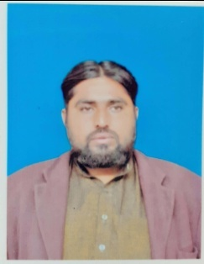

Muhammad noman
Mailing Address: Mohalla kamal khel Tehsil Kulachi Dist: Dera Ismail Khan
Mobile No : 0346-5565529

OBJECTIVE AND AMBITIONS:
- I want to achieve a respectable professional position in the society and in my own region through knowledge, hard work, efficiency, skills and service.

PERSONAL INFORMATION:
- Father’s Name : MEHRBAN
- Date of Birth : 30/03/1988
- C.N.I.C # : 12102-7623990-1
- Domicile : D.I.Khan (KPK)
- Nationality : Pakistani
- Religion : Islam
- Marital Status : Single
- Gender : Male
ACADEMIC QUALIFICATION:

 | $$Type equation here.$$  CERTIFICATE | Marks | YEAR OF PASSING | BOARD /UNIVERSITY
S.S.C |  | 515/850 | 2004 | B.I.S.E-BANNU
F.A |  | 599/1100 | 2006 | B.I.S.E-BANNU
B.A |  | 223/550 | 2008 | Gomal University D.I.Khan
MA |  | 577/1100 | 2010 | Gomal University D.I.Khan

SKILLS:
- MS Office , MS Excel , English Typing , Power Point , Hardware and Software.
LANGUAGE:

- English
- Pashto
- Saraiki
- Urdu

