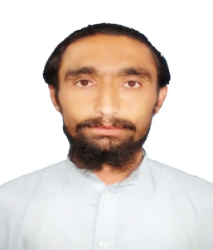Resume

Name : Muhammad Noor

Father's Name : Musam Khan

Address per CNIC : Village Khaisor Manzara, Tehsil Tiarza, Post Office Tiarza,

South Waziristan Agency, FATA, Pakistan

Present Address : Marhaba/Gulshan Bahar Colony, CRBC Canal, Tank Road, Dera Ismail Khan, Khyber

PakhtonKhwa, Pakistan

Mobile : +923038949554, +923000819560

Email : [noormasid@gmail.com](mailto:noormasid@gmail.com)

PERSONAL DATA:

CNIC Number : 21706-6147330-9

Date of Birth : 05-03-1995

Gender : Male

Religion : Islam

Marital Status : Married

Nationality : Pakistani

Languages : English, Urdu and Pashto ⇨ (Writing, Reading, Listening & Speaking)

ACADEMIC DETAILS:

|  |  |  |  |
| --- | --- | --- | --- |
| Exam | Session | Marks | Board/University |
| S.Sc | 2011 | 717/1050 | B.I.S.E Dera Ismail Khan |
| F.Sc | 2013 | 635/1100 | B.I.S.E Dera Ismail Khan |
| B.Sc | 2015 | 288/550 | Gomal University Dera Ismail Khan |

SKILLS:

1) MS Office ⇨ (MS Word, MS Excel & Power Point)

2) Adobe Photoshop

3) Coral Draw

4) Typing ⇨ (English, Urdu, Pashto & Arabic

I do hereby declare that the above particulars are given by me are true and correct to the best of my knowledge, I also assure that I shall do my best and be loyal to the establishment and I serve.