Curriculum Vitae

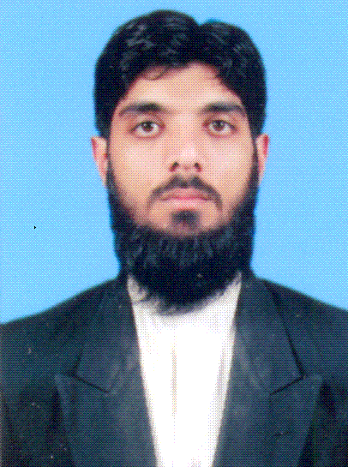 | MUHAMMAD NUMAN  Mohallah Maroof Khel Village Sarki Shulgara Tehsil & Distt Charsadda.  Tel:0315-9023168  Father’s Name: Muhammad Iqbal Jan  Date of Birth:16th Apr, 1987  N.I.C # 17101-1702566-7  Domicile: Charsadda  Religion: Islam  Marital Status: Married  E-mail: numankhan16@hotmail.com

Objective  education  WORK EXPERINCE  ADDITIONAL sKILS  lANGUAGES  other Education  interests  references | To grow and survive in a global competitive environment and to make myself so agile and innovate that can face all the challenges of life while considering the four main things. That is my commitment, my passion, my integrity and my sincerity.  MLISc – 2011  - Peshawar University  B.A – 2008  - Peshawar University  F.A- 2005  - Peshawar Board  Matric - 2003  - Peshawar Board  - Major: Science  - Currently working in Shifa Tameer-e-Millat University Islamabad as Library Assistant w.e.f 1st Jan, 2023  - Working as Assistant Librarian in Punjab College of Commerce 6th Road Rawalpindi from 2011 to 2022.  - Ability to work both group and on individual basis.  - Effective and efficient leadership skills.  - Effective Communication and interpersonal skills.  - Pushto  - Urdu  - English  - 6 Months Computer Diploma From Frontier College of Information Technology  - Travelling  - Sports  Available on request

