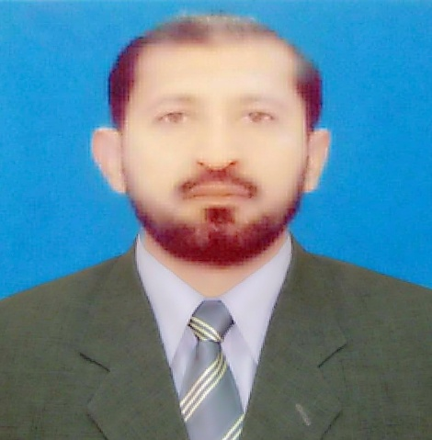

Contact

**Address:**

HOSF, PAF Sector E-9 Islamabad

**Phone:**

+92 321 277 5225

**Email:**

[mrvnsd@gmail.com](mailto:mrvnsd@gmail.com)

**Employment History**

Pakistan Air Force

CECOS University of Engineering

Shaheen Foundation, PAF

Languages

English ⚫⚫⚫⚫⚪

Urdu ⚫⚫⚫⚫⚫

Pashtu ⚫⚫⚫⚫⚫

Punjabi ⚫⚫⚫⚫⚪

Saraiki ⚫⚫⚫⚫⚪

Hobbies

* Sports
* Walking
* Visit Natural places
* Reading

Muhammad

Raza

Professional Summary

Highly efficient and deligent administrative Office professional with 25 years experience in management. Capable leader with excellent skills in delegating responsibilities to others and supervising / evaluating for effective tasks completion for effective task completion. Enthusiasm for delivering excellent service to the customer and other visitors in the office. Commitment to upholding company policies and procedures when working with staff members and motivating team. Strong organizational skills and excellent attention to detail when dealing with paperwork. I can contribute my expertise in administration, management, organizational psychology and human relations and establish a high productive work for the company.

Objective

To work in an Organization as an integral part of it and accomplish the job assigned in a better way. I am looking for a high challenging and dynamic work environment in which I will be able to enhance my professional skills and would be able to get valuable work experiences.

Aim

I want to utilize my theoretical skills and practical knowledge/experience in applied form and looking forward for the bright future that emphasis innovative thinking and originality. My ideal job will be the one that would value “thinking out the box”.

Professional Certification

* Military Command & Leadership, management, law course.
* Administration & Supervisory course.
* Personal Computer course.
* Leadership (SNCOs) course
* Organizational , Office Procedure, trade practical theory, Typing, Maint of office record (Advance) course
* Organizational, Office Procedure and maint/record course.
* Short Hand (Stenographer) course.
* Instruction on Military, trade and Training course.
* Supervisory Management (OJT) course.
* Instruction on General Services Trg, military training course.
* Skill enhancement program management course.
* Ensign Communique (Basic) IT course.

Skills

Ability to work under

pressure

Accuracy

Communication Skills

Good Team

Organizational Skills

Time Management

Cheerful, friendly person

Discipline procedures

Education

BA

Honor & Awards

Democracy Medal

Golden Jubilee Medal

(Resolution Day)

Services Medals

Golden Jubilee Medal (Independence Day)

Tamgha-e-Istiqlal

Commendation Certificate

Cash Awards

Job Preference

* Admin Officer
* Office Manager
* Office Administrator
* Security/Safety officer
* PA/ Secretary
* Manager , Supervisor, Superintendent

**Contact:-**

**📞 +92 321 277 5225**

**📧** [**mrvnsd@gmail.com**](mailto:mrvnsd@gmail.com)

Experience

Administration, Management

* Strong skills in office management and administration.
* Telented in dealing with multiple assignment at once and an ability to meet deadlines and complete accurate work at all times.
* Highly capable oral and written communicator when discussing issues with staff members or delivering correspondence to individuals in writing.
* Guided members when faced with difficent change in their work or when working with members and experiencing a conflict.
* Manages an office with a manpower of personnel to deal with various sections departments of operations, maintenance, Air Defence, logistics, It and Accounts.
* Receives inspects and clears paperwork on all materials delivered to the office.
* Tasked to oversee Admin, Office work.
* Trained and oriented new staff.
* Knowledgeable in basic administration , management principles and fluent in written and spoken.
* Maintains, handling, custodian of important, sensitive and secret documents record.
* Advise personnel on matters pertaining to sensitive issues in work places.
* Responsible for ensuring quality and timely completion of job.
* Supervise all jobs connected with legal matters.
* Work under pressure and complete high level work load with strict deadlines.
* Utilize creativity and provide professional guidance.
* Provides administrative advice to personnel for resolution of issues.
* Draft the letters as per requirements. Distribute the information by using mail services, telephone and email.
* Excellent communication skills of type and handwritten duties.
* Performed the duties as an Admin/Security /MT supervisor at CECOS University Peshawar.
* Security procedures, it's implementation. Surveillance of sensitive areas.
* Efficient and energetic in crises. Operations of small arms explosives.
* Ensures safety the valuable property of organization.
* Fully exercise over MS Word, PowerPoint, Excel, and Internet.