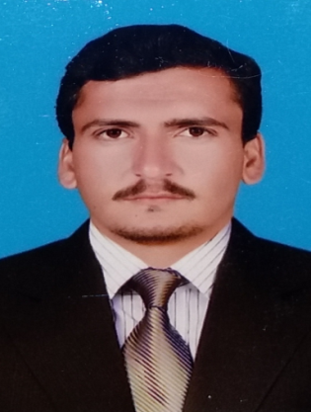 CURRICULUM VITAE

Name **: Muhammad Rehan Khan**

CNIC**: 11201-2089323-1**

Phone **: 03069306510**

Email **:** [**rehanniazi555@gmail.com**](mailto:rehanniazi555@gmail.com)

Adress**: Village Khara UC Daratang District Lakki Marwat**

**QUALIFICATION:**

|  |  |  |  |
| --- | --- | --- | --- |
| Degree | Board / University | Division / % | Passing year |
| Matric | Bise Sargodha | 1st / 70% | 2011 |
| ICS | Bise Sargodha | 1st / 65% | 2014 |
| BSC | University of Sargodha | 2nd | 2015 |
| MSC IT | University of Sargodha | 1st /70% | 2018 |
| B.ed | SUIT | 1st / 71% | 2020 | |
| M.ed | SUIT Peshawar | 1st //75% | 2022 | |
| MS CS | Gomal university DI khan | 3.65/ 2nd  semester | 2022 | |

* 6 month diploma in computer science.

**EXPERIENCE:**

1. **Polio Eradication Initiative Program Lakki Marwat:**

* **2.5 year experience as a Front Line Worker (FLW) In Polio Proram.**
* **One Year Experience in WHO as a LQAS Supervisor district Lakki Marwat.**
* **One Year Experience as Social Mobilizer (SM) in UNICEF based Project known as COMNet.**
* **Since 7 Jun2023 become a Union Council Communication Support Officer (UCCSO) in UICEF based project known as COMNet.**

1. **IN Education Sector:**

* **2 year Teaching experience in The Quaid E Azam Groups Of School And College DI Khan.**

**SKILLS:**

* **OFFICE:**

**MS Word , MS Access , MS PowerPoint.**

* **LANGUAGES:**

**C++ , Data Structure ,OOP**

* **Operating System:**

**Window 7, 8 , 8.1 & 10. , Linux**

**Languages:**

* English
* Urdu
* Punjabi
* pashto

**AWARDS/ACHIEVEMENTS:**

* Got “ **Laptop “** on merit basis in Master, due to scoring above 70% Marks

**FINAL YEAR PROJECT:**

* *Measurement system.*
* *Registration system.*
* *Research On Cardio Vascular Disease Using Machine Learning .*