MUHAMMAD SARFARAZ | 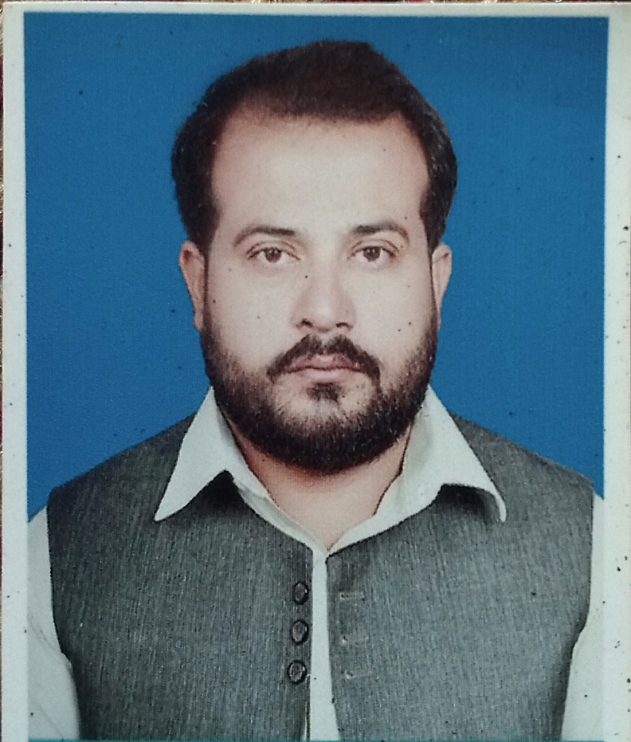
  ▪ Date of birth : December 21, 1990
  Contact
  +92-343-8048830
  Email: farazkhajjak1@gmail.com
  Email:farazkhajjak@yahoo.com
Address
H/no. 26, Labor Colony Nawa Killi Quetta Balochistan Pakistan

Profile
Objective | To use my skills and potential to assist an organization in achieving its goals which seeking long term career with optimum growth. This objective would be supported by my qualification, in addition to the management experience and multi-lingual command.

Education
BBA(Hons) June, 2014
(marketing/finance)
3.22cgpa
Preston University Peshawar Campus
FSC 2009
(pre-engineering)
Percentage: 57%
Warsak Model School & Collage Peshawar
ssC 2007
percentage: 64%
Nizami Public High School Dukki Loralai Balochistan

- Certificate of participating in National Accountability Bureau Peshawar
- Certificate of participating in Cultural Show
- Certificate of participating in Dramas in University
- Certificate of participating in Preston University Literary Society

Additional Certification
Internship report
Six month internship in National Bank of Pakistan Quetta Baluchistan.

Final year project
A report on the IMPACT OF MICRO FINANCE ON SMALL INTERPRISES

Experience

Advocacy and Social Advancement Society (ASAS-Pk)
Designation: Admin & Finance Officer March 2017 to June 2019

RESPONSIBILITIES:

- General Administration
  - Manage administrative function and establish internal administrative systems and controls.
  - Contribute fully to implementation and oversight of technical assistance to partners in the area of management.
  - Assess and provide / manage high quality capacity building inputs to District Staff of the organization
  - Build support for including the ongoing development of the Project networks and stakeholder relationships.
  - Establishment of ASAS-PK Office
  - Ensure the smooth operations of the office
  - Perform additional tasks as required
  - To prepare and communicate monthly, quarterly, and annual report of administration

- Financial Administration
  - Management of bank accounts of the office
Payments and tracking of office expenses, including production of status reports
Drafting of ASAS-PK budget
  - Provision of financial support for events and visits of the district staff
  - Requisition, allocation and return of funds, record keeping of expenses and funds, vouching, and reporting
  - To prepare and communicate monthly, quarterly, and annual report of finance
  - Responsible for administration and smooth functioning of all assets of the office like vehicles, computers, generators etc
  - Calling, arrangement and processing of meetings on various issues and subjects
  - Responsible for procurement for district office and CLCs
  - To communicate work progress of project in the district with project core team
  - Implementation of project objectives at district level

- Human Resource Administration
  - Overall help to ensure human resource needs of the staff are being met
  - Maintain personal files
  - Ensure the policies and procedures of the organization
Liaise with Dutch authorities regarding visas, work permits, and residence permits.
Facilitate staff recruitment

- Management Information System
  - Operation of MIS of Project at district level
  - Facilitate District Team in MIS related activities
  - Giving feedback and suggestions to MIS Coordinator of the project regarding MIS

- Office management
  - Ensure overall infrastructure for the office, manage office supplies and basic equipment
  - Oversight of good administration and procurement
  - Assessing effectiveness and efficiency of office systems
  - Management of relations with Line Departments Officers, stakeholders, social authorities and other relevant actors

First Integrity Title Search Company (FITA LLC)
Designation: Bankruptcy and Title Search of Defaulter: Feb 2013 to June 2015
- Searched county public real estate records using CRD and Title Records databases to determine current vesting and encumbrances.
- Completed foreclosure searches for county treasurers.
- Searched grantor/grantee and land transfer books at counties.
- BKY search.
- Trained new employees.
- Teaching at School
- NBP Internship

Technical Skills
MS Office:  MS Excel, | 60WPM  Operating systems
MS Word,  PowerPoint.  Computer Basic  Web browsing  Programming | Windows 98, window 8, window7,XP  Vista etc…

Languages
Urdu | English | Pashto Sindhi Sirayki

