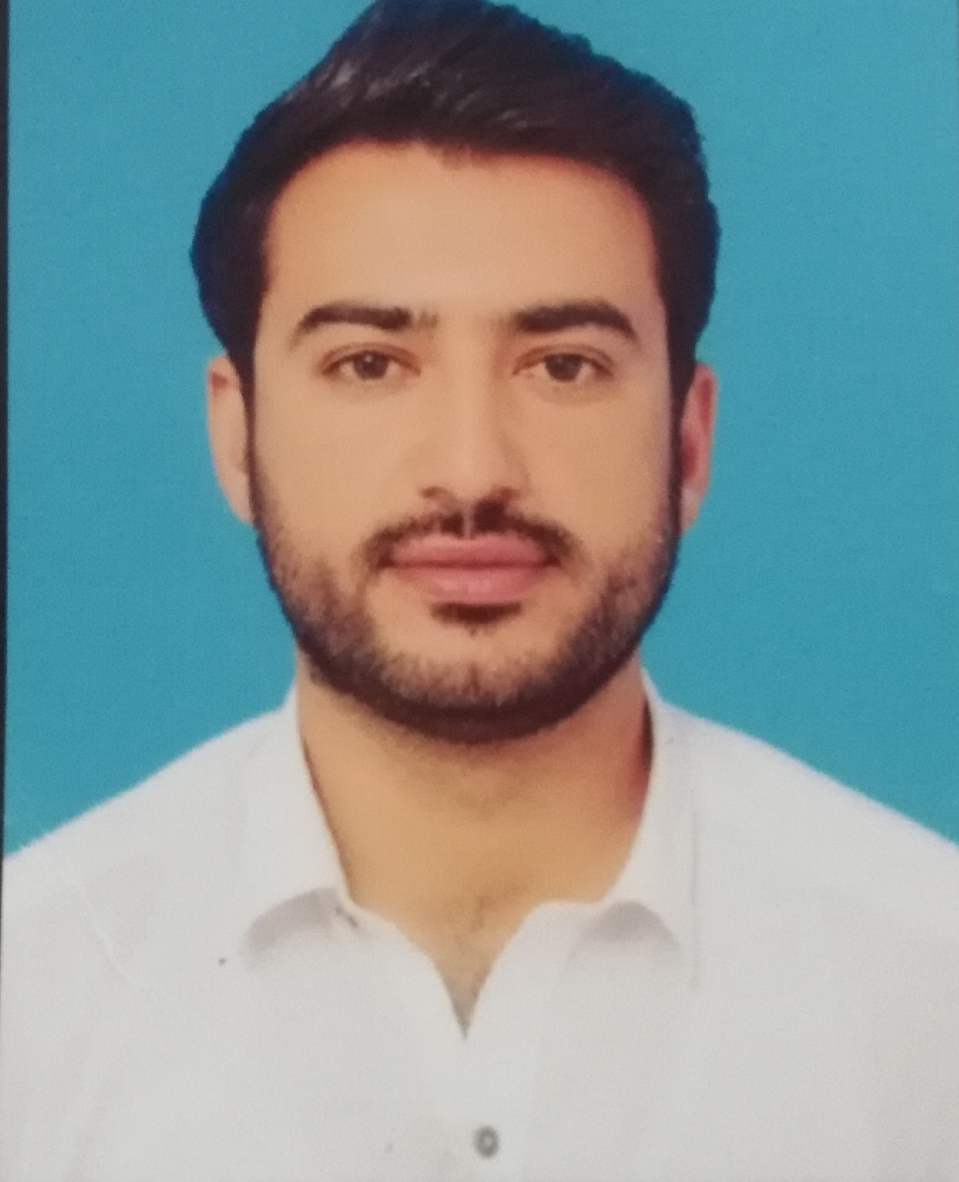

Professional Profile

MUHAMMAD SHABEER

Program Management/Implementation/ Administrative support

(92) 345 – 9091826 [Shabeerkhan1232017@gmail.com](mailto:Shabeerkhan1232017@gmail.com)

SUMMARY

I am confident that I am fully qualified and will be strong addition in your team. I have worked in different organization till to project date. I have six year experience in Private sector organizations and NGOs in General Food Distribution, Managing and computer operator. I have B.S Honors degree in Statistics from University of Peshawar, and also having computer literacy. I would appreciate a job interview at your convenience.

OBJECTIVES:

TO SECURE A POSITION IN AN ORGANIZATION THAT WOULD FULLY EMPLOY MY PERSONAL SKILLS MY EXPERIENCE AS WELL AS MY ACADEMIC TRAINING IN A REWARDING CAREER THAT AFFORDS PROFESSIONAL & PERSONAL GROWTH.

To pursue a challenging career in a dynamic and progressive organization/department. By constant learning and hard work, and to work devotedly to fulfill the organizational/departmental and personal goals, I am looking for an opportunity that would help me to build up my skills and enjoy the growth of my career.

It is because my previous job experience has strengthened my communication skills and has challenged me to work in a dynamic, challenging and demanding environment, lonely/ solitarily or in a group/ team.

Personal Information:

Father’s Name : Sardar Khan

Date of Birth : 10 April 1993

Religion : ISLAM

Nationality : PAKISTANI

CNIC# : 17301-6344335-9



Education:

S.S.C (Science Group)

B.I.S.E PESHAWER (2010) Marks :(611/1050)

F.A (Inter-Science)

B.I.S.E PESHAWER (2012) : Marks :(585/1050)

B.S (Statistics)

PESHAWAR UNIVERSITY (2016) : CGPA: (2.5)



WORK EXPERIENCE

World Health Organization as a post of Temporary Tehsil Monitor (TTM)

Pakistan Polio Eradication Initiative Program in Peshawar

OCT 2017 – 10 JAN 2019

Recruiting staff, which involves developing job descriptions and person specification.

Conduct initial orientation to newly hired employees.

Employee safety, welfare, wellness, and health reporting.

To coordinate with government institutions.

Process documentation and prepare reports relating to personnel activities (staffing, recruitment, training, performance evaluations etc.).

Deal with employee requests regarding human resources issues, rules, and regulations.

Ensure organization is in compliance with legal requirements.

Supportive Supervision during field activities in intra campaign days.

Field validation of micro-plan in pre-campaign phase.

WORK EXPERIENCE

Duration; 14-Jan-2019 till 18-April-2021

Organization: CHIP Training & Consulting Pvt. Limited

(Global Polio Eradication Initiative)

Job Title: Union Council Social Mobilizer (UCSM)

Responsibilities:

Facilitate and pre–Campaign Trainings of Front Line Workers (FLWs) on interpersonal communication (IPC) and counsel the staff regarding chronic refusal with support from community influencers for convincing, conversion and vaccination.

Conduct Training Need Assessment (TNA) for FLWs and Communication staff through available data, field observation, monitoring feedback and regular campaign review with a special focus on communication.

Provide on job training and support to Frontline Workers and Social Mobilizers

Support and facilitate centralized induction/refresher training for Social Mobilizers and House to House Social Mobilizers

UC Micro plan updated with social maps and UC profile.

Social mobilization plans available for the UC for the campaign.

Number of community engagement activities organized VS Facilitated and attended.

10% analysis of the tally sheets/ missed children lists per day during campaign done.

Mobilization of influencers to accompany teams for refusal conversion.

Refusals converted among recorded.

Prepare evidence-based UC social mobilization/ CE plan and make it part of the UC micro plan.

Regularly conduct and updated challenge mapping exercise.

Assist in strengthening routine EPI in the assigned Union Council.

Worked as an UCSM with CTC in EPI/PEI program from December 2019 to April 2021.

UNICEF as a post of Union Council Communication Officer (UCCO)

Pakistan Polio Eradication Initiative Program

10 Jan 2019 – till date

Responsible for community’s social mobilization process for project/program implementations.

Gather data during needs assessments, baseline studies, and periodic studies, and help feed back findings to stakeholders.

Encourage the participation of community members throughout the program

Organize and supervise other office activities.

Formation of project implementation committees and ensuring that committee is proactive in all the activities implementation.

To solve the field level problems.

Liaise with community leaders and other sectors and agencies working locally.

To ensure the accountability at every step of the project.

Record keeping of the raw materials/distribution of varies relief and shelters materials.

To prepare daily field visit reports.

To conduct Regular field monitoring visits to ensure the quality work.

To ensure timely sharing of information.

HOBBIES

Studying books and newspapers. Doing social, developing, welfare and humanitarian Works, playing football, Morning exercise, using internet and social media.

DECLARATION:

I hereby declare that all the details furnished here are true to the best of my knowledge and belief.