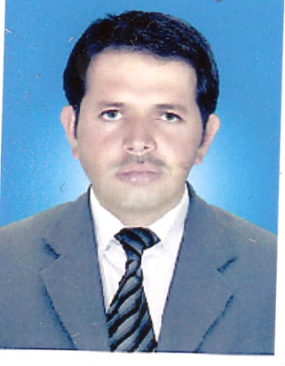**Curriculum vitae**

**Personal information:**

Name : Muhammad Tahir Khan

Father’s Name : Azim Khan

Date of Birth : 15-06-1983

Domicile : Lakki Marwat

Nationalty : Pakistani

N.I.C No. : 11201-0344775-1

Religion : Islam

Marital Status : Married

Postal Address : c/o Zia Ur Rehman, Lecturer in English,

Cadet College Kohat, Kohat. KPK.

Permanent Address : Vill: Adam Zai, P/O Tajori, Distt: Lakki Marwat

**Contact No : 0345-9812952.0345-9644962**

**Educational Qualification**

|  |  |  |  |  |  |
| --- | --- | --- | --- | --- | --- |
| **Degree** | **Board/University** | **Marks Obtain** | **Grade/Division** | **Year of Passing** | **Subject** |
| **S.S.C** | **B.I.S.E Bannu** | **562/850** | **1st** | **2000** | **Science** |
| **F.sc** | **B.I.S.E Bannu** | **569/1100** | **2nd** | **2003** | **Stats, Maths** |
| **B.sc** | **Gomal University** | **332/550** | **1st** | **2006** | **Maths A & B** |
| **B.ed** | **AIOU, Islamabad** | **620/900** | **1st** | **2011** | **General** |
| **M.Ed** | **AIOU, Islamabad** | **744/1200** | **1st** | **2017** | **Science Education** |

**Experience:**

* Working as Clerk-cum-Cashier in Sharif International, Rawalpindi since 2013.
* Worked as Science (Maths) teacher since 2008 to 2012 in Al-Madina Education Academy and College, Bilitang, Kohat.

**Computer Skills:**

MS Office (MS Word), Internet

**Languages:**

English, Urdu, Pashto