

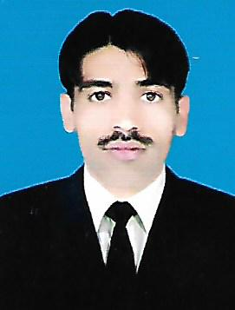

Address: Mohallah Gul Baz P/O & Tehsil Serai Naurang

District Lakki Marwat

Contact: 0306-7669420

**CAREER OBJECTIVES**

To obtain the position of a Medical Representative in a reputed organization where I can use my acquired experience and abilities to benefit the organization

**PERSONAL INFORMATION**

Father's Name: **Dost Muhammad Khan**

Date of Birth: **01-04-1987**

CNIC No: **11201-8306475-9**

Religion: **Islam**

Nationality: **Pakistani**

Marital Status: **Single**

Gender: **Male**

Domicile: **Lakki Marwat**

Languages:  **Pashto, Urdu, English**

**ACADEMIC QUALIFICATION**

|  |  |  |  |  |
| --- | --- | --- | --- | --- |
| Degree | Passing Year | Obtained Marks | Total Marks | Board/University |
| Matric | 2005 | 510 | 1050 | BISE Bannu |
| F.A | 2008 | 538 | 1100 | BISE Bannu |
| B.A | 2010 | 282 | 550 | UST Bannu |
| M.A | 2014 | 650 | 1100 | UST Bannu |

**EXPERIENCE**

* Recently I am working as a "TTM" in UC Mama Khel since 2014.

**COMPUTER SKILLS**

* Three Months Computer Course in Office Automation.
* Three Months Typing Course.
* 01 Year Experience as a Supervisor Department WHO