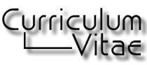

Mr. Muhammad Zaheer
 | PERSONAL INFORMATION
Fathers Name |  | Ahmad Bashir
Date of Birth |  | 23 April 1986
Domicile |  | D.I.Khan, K.P.K
Nationality |  | Pakistani
NIC # | 12101-2001070-3
Residential/Postal Address |  | Mustafa Abad P/O Muryali DIK
Personal Contact # | 0346-7861301, 03119117097
E-mail |  | jawadzaheer1301@gmail.com
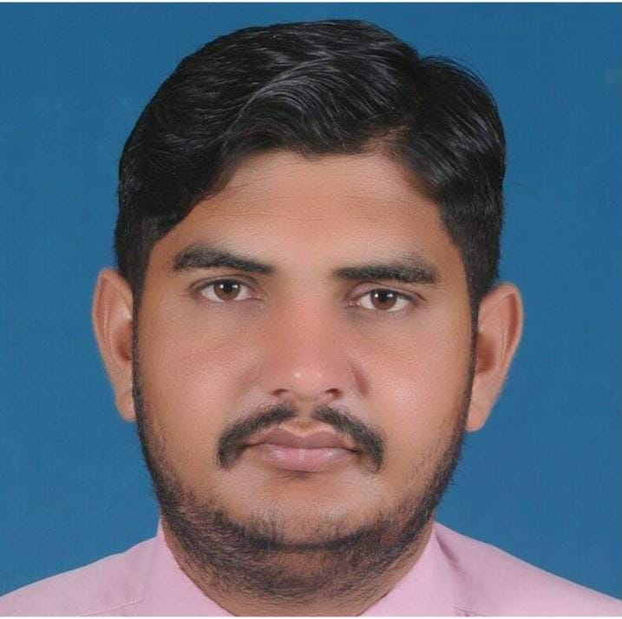

OBJECTIVE
I | am a | young | master, self-motivated, and value-added |  |  | person, have an objective to |  | excel
in | my | field | through sheer | hard work. | Therefore, | I wish | to join a well-reputed
organization for |  |  | continuous | improvement of | my Professional |  | Knowledge, exposure, | and
Skills.

EDUCATION
2010 MA (Islamiat)

Gomal University DIK

Division: 1st

2008 BA

Gomal University, DIK

Division: 1st

2006 DAE (Electrical)

UPI Dera Ismail khan

BTE Peshawar

Division: 1st

2003 Matriculation in Science (S.S.C)

Wensam Collage

Board: BISE Bannu

Division: 2nd

1
 | COURSES / DIPLOMAS
2010 | Office Automation from petromen
2021 2 years Freelancing course from booster academy

SKILLS HIGHLIGHTS

• Strong Decision Maker • Programme Development
• Programme Management

• Planning and Implementation

• Good Government Liaison • Work Under Stress

COMPUTER SKILLS
• | MS-Office (xls.doc.ppt) | • Internet search and E-mail | • Browsing
• | Network Troubleshooting | • Software installation(windows/Packages etc) | • Coral Draw
• Google Forms, Spread Sheets |  | • IT equipment’s (printers, scanners) | • In-page

LANGUAGE PROFICIENCY
 |  | ◑Speaking |  | ◑Reading |  | ◑Writing
• | Urdu | Excellent |  | Excellent |  | Excellent
• | English | Excellent |  | Excellent |  | Excellent
• | Saraiki | Excellent |  | Excellent |  | Excellent
• | Punjabi | Excellent |  | Excellent |  | Excellent
• | Pashto | Good |  | Average |  | Average

WORK EXPERIENCE
1- Working as T.P.O (Tehsil Polio Officer) (From 01-Jan-2023 to till now)

Job description
- Coordination and Leadership

  - Provide Technical Support to the Tehsil Polio Eradication Committee on poliomyelitis eradication.

  - Work closely with government and partners to ensure coordination of different stakeholders in the assigned area.

  - Ensure the functioning of the TPEC in the assigned areas.

  - Support the full implementation of the National Emergency Action Plan (NEAP) and other key policy documents on polio eradication and immunization at the assigned level.

2

- Supplemental Polio Vaccination Campaigns (SIA)

  - Support the TPEC in ensuring the timelines for SIA activities are formulated and followed in the assigned areas.

  - Ensure appropriate selection of vaccinators and supervisors as per the NEAP guidelines.

  - Facilitate and monitor the training's of teams, AICs, and other categories of health workers.

  - Provide technical support to pre-campaign activities particularly planning, preparing and monitoring the quality of area level Micro-planning, at the union council and tehsil levels.

  - Monitor the effective utilization of mobile, fixed and transit teams in the assigned areas, and immediately report misuse to the immediate supervisor.

  - Formulate an appropriate plan for coverage of missed children.

  - Work closely with the communities in the assigned areas to rebuild trust in vaccines, combat misinformation and generate demand for polio vaccination Mobilize religious, tribal and political leaders, and other influential persons in the assigned area to support polio eradication.

  - Support the TPEC in access negotiations in the assigned areas.

  - Formulate a daily priority-based supervision and monitoring plans of the AICs and UC teams to ensure support to poor performing areas and motivation of teams.

  - Supervise and monitor the work of the teams, AICs and UCSPs, take household clusters and at the same time validate a sample of the clusters and missed children coverage done by the UC team.

  - Ensure all reported missed and poorly covered areas are investigated, and re-vaccination/sweeps carried out. Analyze the daily data and collate the observations of the UC teams and present the findings, actions and recommendations at the daily evening meetings.

  - Provide special focus on the high-risk populations during all the phases of the campaign in line with the special strategies devised for risk populations and the National Emergency Action Plan for Polio Eradication, including supervision of PTPs/TTPs.

  - Carry out a post campaign analysis of data, review reports, collate, summarize, and disseminate the report to be shared with the authorities in the assigned areas.

  - Follow up with respective tehsils/UCMOs in timely filling of DDM cards and submission.

  - Support vaccine management at the Tehsil level

- AFP Surveillance

  - Under the guidance of the Surveillance Officer or the IO (Immunization Officer), support the establishment of community-based AFP Surveillance system in the assigned areas.

  - Support the Surveillance Officer and IO (Immunization Officer) in ensuring timely stool/environmental sample collection and transportation as per the SOPs and guidance of the supervisor.

  - Conduct regular surveillance visits to assigned areas as per the monthly surveillance work plan.

  - Participate in detailed epidemiological investigations as determined by the immediate supervisor

  - Train/sensitize the informal health care givers on AFP surveillance.

3
  - Ensure mapping and inclusion of all formal and informal health care providers in the assigned area in the AFP surveillance network.

- Essential or Routine Immunization

  - Support the IO in strengthening of essential/routine immunization through participation in the development of micro plans for implementation of REC/RED approach.

  - Ensure monitoring of EPI coverage and drop-outs

  - Support the TPEC in engaging and mobilizing communities RI demand creation and building the trust of communities in vaccine uptake.

  - Assist the UCMOs in prioritization of UCs that are poorly performing

  - Identify zero dose and under immunized children in the assigned UCs and refer them for immunization.

- Other activities

  - Helped and monitor other EPI activities i.e.
    - Measles OBR Micro-plannings, Implementation and monitoring.

    - MR (Measles Rubella) SIA trainings

    - MR Micro-planning and Validations (Desk & Field)

    - MR SIA monitoring and supervision.

2- Worked as U.C.P.O (Union Council Polio Officer) (From 01-March-2015 to 04-Dec-2022)

- SIAs (Supplementary Immunization Activities)

  - Micro-planning:- Assist in preparation and updating SIAs micro-plans, validate micro-plan in the field. Help in identifying and mapping high-risk areas in UC.

  - Teams selections:- Assist in the selection of appropriate vaccinators as per the NEAP indicators and their distribution as per need.

  - Training:- Assist the PEOs (Polio Eradication Officers) and district trainers in planning, coordinating, and organizing training sessions for vaccination teams and supervisors.

  - Implementation of SIAs:- Ensure proper implementation of SIAs with special attention to hard-to-reach areas and underserved high-risk populations.

  - Monitoring and Supervision:- Campaign Implementation, Monitoring:- monitor the process of implementation of the campaign as per guidelines and provide feedback to PEOs.

  - Meetings (UC Level / Tehsil Level):- Attend the daily evening review meetings at UC level for every SIA (Special Immunization Activities) and record the findings/observations for corrective action on the following day of the campaign.

  - Missed children Tracking / Challenge Mapping:- Participate in the preparation of realistic catch-up plans for missed children and monitor their implementations.

  - Post Campaign phase:- Participate in organizing the re-do/sweeping activities in the UC as required in the light of PCA/LQAs/Market Survey (Post Campaign Assessments/Lot Quality Assessments) results and validation of missed children's (NA/Ref).

4
  - Facilitate and support the work of externals/ independent monitors.

  - Follow up and real-time reporting to PEO (Polio Eradication Officer WHO) regarding issues identified in the field along with their rectification and their way forward.

- Data collection and analysis

  - Collect and collation the data from the Team/Area/UC level.

  - Analyzing the data on daily basis and reporting the findings, action taken, and recommendations to UCMO and district data team.

  - Risk Profiling and Challenge Mapping

- AFP Surveillance

  - Ensure Timely submission of VPD Zero Report from assigned HFs. Also, visit the informal health care providers to support community surveillance in light of timely reporting of Vaccine-preventable diseases (AFP/Measles/NNT).
  - Follow-up of the notified/reported VPD cases

  - Participate in detailed epidemiological investigations.

- Essential Immunization (EI)

  - Assist in RED/REC Micro-planning to strengthen the essential immunization

  - Field Validation of RED/REC Micro-planning to ensure no child is missed

  - Support in Outreach activities on as per RED/REC

  - Verification of zero-dose children's and defaulters

- Communication Activities

  - Arranging the community engagement sessions based on challenge mapping.

  - Arranging the small community engagement sessions in the pre-campaign phase.

  - Good liaison with local influencers (Nazim/HCPs/Local RSPs/Teachers/Local Bodies) and involving them in support of refusal coverage

5

TRAINING/ACHIEVEMENTS/AWARDS
• | 2023 | United to Respect Preventing sexual harassment and other prohibited conduct | Position: T.P.O
 |  | For managers Certificate (Online)
• | 2023 | Prevention of sexual exploitation and abuse (PSEA) certificate (Online Training) | Position: T.P.O
• | 2023 | UN BSAFE Certificate (Online-Training) | Position: T.P.O
• | 2023 | Awarded Certificate of appreciation for best performance by DC DIKhan | Position: T.P.O
• | 2016 | 3 Day Training Of Trainer TOT at Shelton Green Hotel Peshawar | Position: U.C.P.O
• | 2023 | Certificate of appreciation for best performance in the Polio program at UC Tehsil Level | Position: T.P.O

REFERENCES
Dr. Sardar Alam (Technical Officer SKP-Bannu Hub)

Cont: +923349142143, Email: salam@who.int

Dr. Nabeel Liaqat (District Coordinator DIK)
Cont: +923015776613, Email: liaqatn@who.int

Dr. Jamshed Noor - Disease Surveillance Officer (DSO-KARAK)

Cont: +923339316545, Email: Jnoor43@gmail.com

Dr. Waqar Ahmad Khan (Immunization Officer)
Cont:03334212329
Sikandar Ali Khan (PDA DIK DIV)
Cont: +92336979934, Email: pda.dikhan@gmail.com

6

