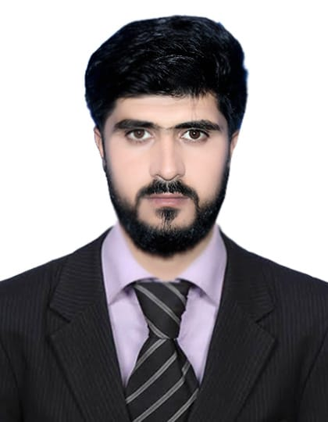

**C**

**URRICULUM**

**V**

**ITAE**

***Muheen Khan***

03146143163

Email: muheenkhankakar@gmail.com

**OBJECTIVE**

To work with a well reputed organization where I can use may knowledge and strength for the betterment of not only my future but also for the betterment of organization.

|  |  |
| --- | --- |
| **Father’s Name** | **Muneer Ahmed** |
| **Marital Status** | **Single** |
| **Nationality** | **Pakistani** |
| **Religion** | **Islam** |
| **Gender** | **Male** |
| **CNIC** | **54302-1396387-5** |
| **D.O.B** | **06-03-1998** |
| **Domicile** | **Pishin ( Balochistan)** |
| **Address** | **Satellite Town Quetta** |

**PERSONAL DETAILS**

**ACADEMIC QUALIFICATION**

|  |  |
| --- | --- |
| **Degree** | **Board/University** |
| **Matric** | BBISE Quetta  Islamia Boys H/s Quetta (Science Group) |
| **FSc** | BBISE Quetta  Islamia Boys College Quetta (Pre- Medical) |
| **BA** | UOB |
| **BSc** | Govt Science College Quetta |
| **B.ed Hons** (2.5) | UOB |
| **MA English literature** | UOB |
| **Advance Diploma** | The Voice of Wisdom English Language Academy |

**Experience**

* The Moon Light H/s Quetta (Duration 02 Years)
* Iqra Public School Quetta (Duration 02 Years)
* Allama Public School Quetta (Duration 04 Years)
* The Hawks English Language Academy Quetta (Duration 02 Years)

**LANGUAGES**

* English
* Urdu
* Pashto