|  |
| --- |
| **Mumtaz Ahmed** |

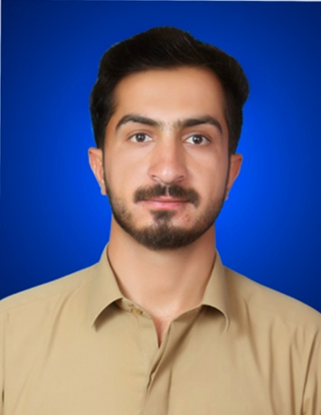

|  |
| --- |
| **AIMS & OBJECTIVES** |

To work with a leading organization providing good opportunity as a team member where I can learn and improve my skills and hence add value to the organization.

|  |
| --- |
| **PERSONAL PROFILE** |

* **Father’s Name Haji Muhammad Umar**
* **Date of Birth 13-05-1998**
* **CNIC # 51602-6363157-9**
* **Domicile Mastung (Baluchistan)**
* **Marital Status Unmarried**
* **Nationality Pakistani**
* **Religion Islam**
* **Permanent Address killi Sufaid Bolandi Mastung, Balochistan.**
* **Cell # +923350066076**
* **E Mail:** [**mumtazbangulzai8@gmail.com**](mailto:mumtazbangulzai8@gmail.com)
* **Passport # ST1811572**

|  |
| --- |
| **ACADEMIC RECORD** |

|  |  |  |  |
| --- | --- | --- | --- |
| DEGREE | Marks/CGP | YEAR | BOARD/UNIVERSITY |
| Matric | **648/1050** | **2014** | B.B.I.S.E Quetta |
| F.Sc | **664/1100** | **2016** | B.B.I.S.E Quetta |
| B.A | **436/800** | **2020** | UOB QUETTA. |
| MA English Literature | 2.7/4.OO | 2021 | UoB QUETTA. |
| B.ED | 2072/ 3000 | 2022 | AIOU |
| B.P.ED | 582/100 | 2023 | UoB QUETTA. |

|  |
| --- |
| **EXPERIENCE& Other Diplomas** |

* **Six Months Diploma in Computer from TTCB.**
* **One Year Experience of Teaching at Gov: H/S Wali Khan Mastung Road Mastung under prime minister youth training scheme.**
* **One year experience of Teaching at Cambridge H/S Quetta.**
* **One year experience of teaching at A-one City model H/S Quetta.**
* **One year experience of Social Mobilizer in UNICEF polio Program.**

|  |
| --- |
| **LANGUAGES** |

* **English,**
* **Urdu,**
* **Balochi**
* **Brahvi**

|  |
| --- |
| **Skills** |

**Microsoft Office and Graphic’s e.g. and Composing  
 Microsoft Office 2013 and latest.  
 Network Designing.**

**Corel Draw .**

**Adobe .**

**Internet:**

**Mozilla Firefox, Google Chrome, Opera Mini  
Gmail, Face book, Twitter, Yahoo Messenger.**