MUSA ZAMAN



* Email: [korarutakoizo@gmail.com](mailto:korarutakoizo@gmail.com)
* Linkdin : <http://www.linkedin.com/in/musazaman>
* Contact number: 03312004355
* Address (Work): Old Haji Camp Sethi twon Peshawar
* Address (Home): Peshawar,Pakistan
* Date of Birth: 18/03/2001

# Education

**2019-2023**

**Bachelor of Science** in Information Technology (**BSIT**)

**Agriculture University** **of Peshawar**

3.01 CGPA.

**2021-2022**

**Diploma**: Information Technology **(1 Year)**

**Cecos Data Institute Peshawar**

Pass with 1st Division

**Grade (A)**

**2017-2019**

**Intermediate**: PRE-Engineering

**The Muslim College Of Computer Science Peshawar**

Pass with 1st Division

**Grade (C)**

**2015-2016**

**Matriculation :** Science Group

**Pakistan Intenational public School Peshawar**

Pass with 1st Division

**Grade(B)**

**Language**

**• Pashto | Urdu | English**

**About Me**

Motivated and adaptable Information Technology graduate with a solid educational foundation from a Bachelor's degree in Information Technology and a Diploma in Information Technology. Eager to contribute my technical expertise, problem- solving skills, and passion for technology to a dynamic team. As a diligent learner with a proactive attitude, I am committed to embracing challenges and continually enhancing my abilities in a professional environment.

**Skill**

* My expertise in HTML,CSS,JAVA SCRIPT, PHP, MYSQL .Computer tools word,power point etc,, I have recently done my final year (DIT) project in Visual Studio and I design the CV-Generator using HTML,CSS,JAVASCRIPT .
* AS well as i develop Fast Food Website using PHP,HTML,CSS, MYSQL during my Semesters in (BS IT).

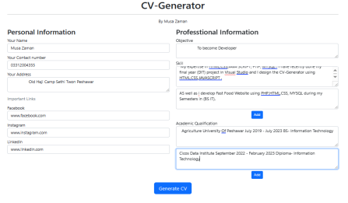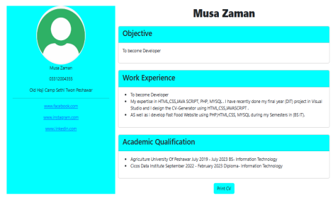

**Computer skill**

Proficient with Microsoft Word , Excel ,Visual studio, Virtual Box, Chrome, Visual Studio code, Sublime Text and any type of software or tool. My typing speed is also very good.

**Work experience**

Livingston Research, March/2023 - Jun/2023 I worked as a Freelancer.•

Did diffrent type of projects for higher and secondary Students