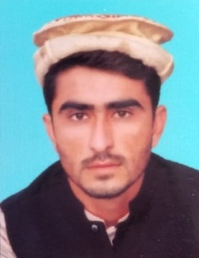
CURRICULUM VITAE

NAQIB ULLAH

OBJECTIVE
I am quite reliable, committed, a keen learner and hard working. I can also work in a busy environment and under pressure. I have good communicated skills and have the capability of working alone or being an effective team player.

PERSONAL DATA
- Father’s Name : GHULAM JAN
- Contact No : 0340-9409283
- Whatsap No : 03085726051
- Date of Birth : 13-12-1999
- Domicile : Tank (KPK)
- C.N.I.C # : 12201-2329289-9
- Marital Status : Un Married
- Religion : Islam
- Nationality : Pakistani
- Mailing Address : Village Shah Alam Tehsil & District Tank.

ACADEMIC QUALIFICATION

Degree | Year | Marks | Board
S.S.C | 2016 | 702/1100 | B.I.S.E, D I Khan
F.A | 2021 | 674/1100 | B.I.S.E, D I Khan
B.COM | 2023 | 1270/1800 | A.I.O.U ISLAMABAD
D.I.T | 2020 | 1160/1400 | B.T.E PESHAWAR
6 Month Diploma in Electrical | 2021 |  | T.T.B PESHAWAR
EXPERIENCE
- 3 Months Diploma Accounting in FCW Tank
LANGUAGE SKILLS
- Urdu, Pashto, English, Saraiki

