Qazi falal niaz
Curriculum Vitae 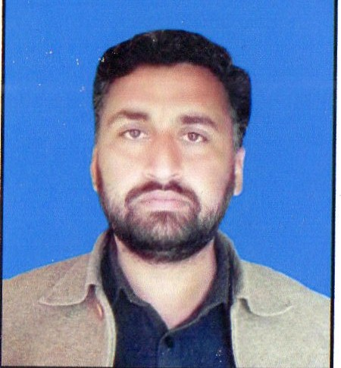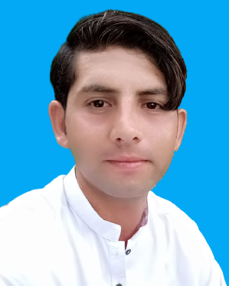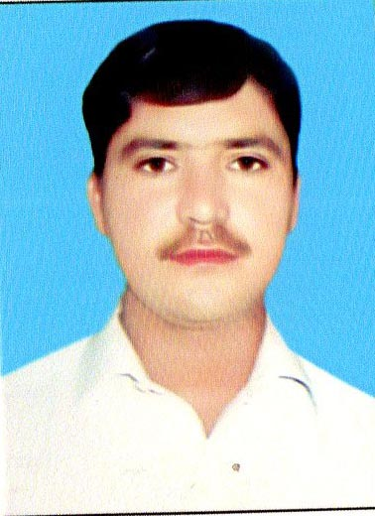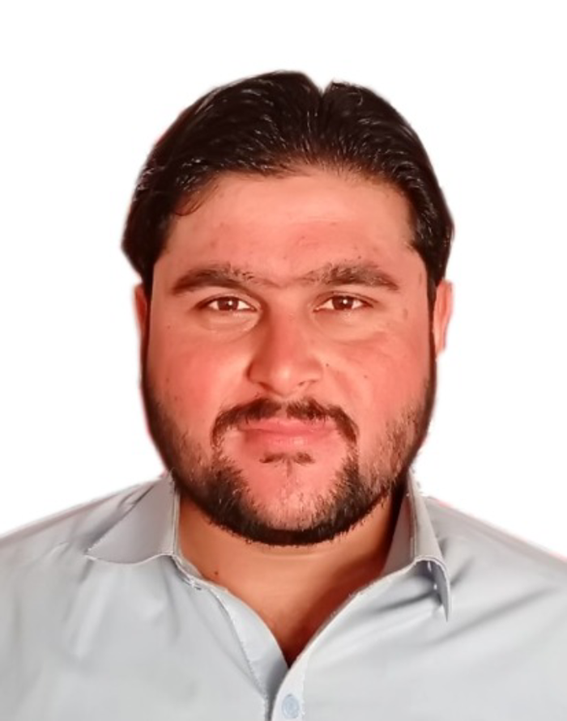
Contact No: 0300-0523448
Address: . Village and P/O sheikh Mohammadi, Mohalla Ghunda Khel, Peshawer, KP.

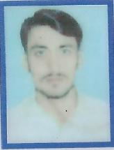
OBJECTIVE:
To become a part of a dynamic group where I could further explore the skills and capabilities to server in a challenging work environment and to gain equally vast opportunities of career development based upon achievements and results.

PERSONAL INFORMATION:
- Fathers Name : Qazi Falak Niaz
- Nationality : Pakistani
- Date of Birth : 04th March,1986
- NIC No : 17301-1419886-5
- Religion : Islam
- Gender : Male
- Domicile : Peshawar
- Marital Status : Married
- Email : qazifalakniaz@gmail.com
Degree/ Certificate | PASSING YEAR | Board/University
S.S.C  F.Sc  B.A  M.A English | 2002  2004  2007  2019 | BISEP  BISEP  University of Peshawar  National University of Modern Languages (NUML)
EXPERIENCE:
Four Year experience in Polio as a Temporary Tehsil Monito
Three Year Experience in Polio as an Union Counsil Communication and support Officer in UC Sheikh Mohammadi (UCCSO) with CTC.
One Year Experience in Polio as an Union Counsil Delivery and Operational Officer (UCDO) in UC Sheikh Mohammadi with People Organization.
Till date working as an Union Counsil Operation Officer (UCOO) in UC Suliman Khel, with CTC.
LANGUAGE:
- Urdu
- Pushto
- English

