RAHEEL  MEHMOOD | 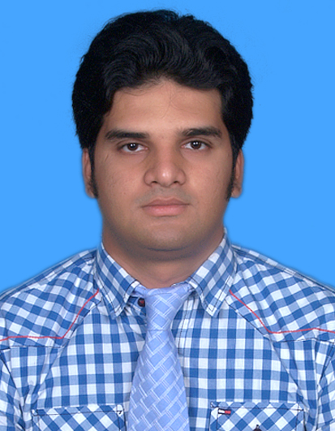

Contact
Cell: +92-3343921944
Tel: 0812-449857
e-mail : raheelmehmood32@yahoo.com
Address
House#510, W-2, Block#3, Satellite Town, Quetta

Profile
Objective | I am seeking a position in a leading, expanding and progressive organization where I could contribute my skills and capabilities for the accomplishment of its goals along with opportunity for learning, development and growth dedicated towards sound growth of the organization with utmost care and highest professional standards.

Professional Certifications & Academics Education
QUALIFICATION INSTITUTION CGPA/DIVISION
Master in Business Administration (Finance) 2011-2012 | Bahria University, Karachi CGPA:3.46/4
Bachelor of Business Administration  (HONS) (Finance) 2007-2010 | Bahria University, Karachi CGPA3.37/4
F. Sc (Pre-Engineering) 2005-2006  Matric 2003-2004  CERTIFICATION  Certification in Basic Engineering Concepts Course for Non-Engineers Sep 2012-Oct 2012 | General M. Musa Govt. Inter College Second Division  Quetta  Govt. Technical Model High School Second Division  Quetta  Wapda Staff College/Ghulam Ishaq Qualified  Khan University, Islamabad
Operation Manager Certification  Nov 4th 2019 - 9th Nov 20219 | TMDD Bank Alhabib Ltd Karachi Qualified

Work Experience
Meezan Bank Ltd.
Operation Manager (Assistant Manager-1) September 29th ,2021 to Present
- Currently, I was working as Operation Manager (AM-1) that includes authorization of cash, clearing, Transfer, Home-Remittance, Banker`s Cheque & Call Deposit etc.

United Bank Ltd.
Business Analyst (OG-1) March 1^{st,} 2021 to 23rd September 2021
- Previously, I was working as Business Analyst (OG-1) in United Bank Ltd Regional Headquarter Quetta.

Bank AL Habib Ltd.
Operation Manager (OG-1) January 1st ,2020 to 23 Feb 2021
- I was working as Operation Manager (OG-1) that includes authorization of cash, clearing, Transfer, Home-Remittance, Banker`s Cheque & Call Deposit etc.

Operation Manager (OG-2) September 5th ,2019 to 31st December2019
- I was working as Operation Manager (OG-2) that includes authorization of cash, clearing, Transfer, Home-Remittance, Banker`s Cheque & Call Deposit etc.
Bank AL Habib Ltd.
Remittance Officer (OG-2) | August 31,2016 to September 4th 2019
- I was associated with General banking that include Clearing, Transfer, Home-Remittance, Reporting ATM Balancing through System & Micro Soft & Proceeding Banker`s Cheque & Call Deposit etc. & Currently giving training to New Entrance of BAHL Quetta region.
United Bank Ltd.
Customer Service Representative (OG-3) November01,2014 to April14,2016
- At that time, I was associated with General banking that include Clearing, Transfer, Home-Remittance etc.

United Bank Ltd.
Retail Banking Officer (OG-3) October30,2013 to October30,2014
- On-the-Job training of one year in General Banking.
ISMAR Financials Ltd, Karachi
Management Trainee December 3,2012 to February 4,2013

MCB Bank Ltd.
Six Week Internship July 20 to 31 August 2011
United Bank Ltd.
Six Week Internship July 2 to 14 August 2010

Areas of responsibilities
- General Banking
- Proceeding Inward & Outward Clearing
- Local & On-line Transfer
- Preparation & Cancellation of Bankers cheque & Call deposit Receipt
- Preparation of weekly & monthly balancing & maintain record for audit trial
- Reporting ATM Balancing through system and maintain record for audit trial

Computer Skills
MS Office Excel, Word, Power Point
Outlook Microsoft

Personal Information
Father’s name | Muhammad Rashid Siddiqui
Date of Birth | 12-03-1988
CNIC #  Domicile | 54400-8504002-3  Mach (Kacchi)
Nationality | Pakistani
Marital Status | Married
Interests | Reading books & playing cricket

References
- Will be furnished upon request.

