Rafiq ullah
Address: 5-BRM Plaza Khyber Super Market Bara Road, Peshawar cantt. Pakistan.
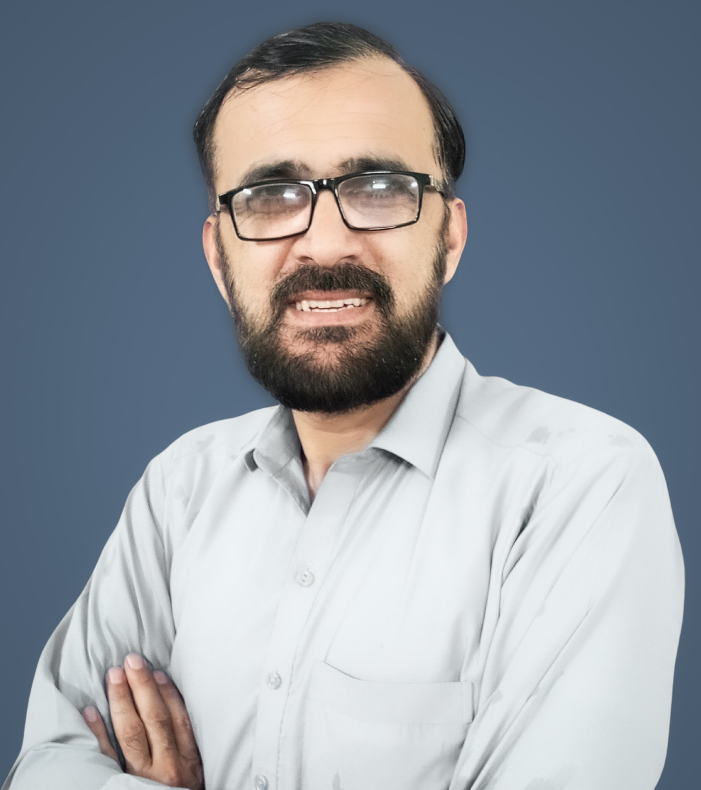
Mobile: 0092-331-9803208, 0333-9178554
E-mail: rafiqullah1@gmail.com

Personal:
Father Name Jawat Mir
National Identity Card: 17301-6750270-3
Date of birth: Jun 08, 1978
Gender: Male
Nationality: Pakistani
Marital Status: Married

Experience

- Currently working as Data analyst at KPIAIP govt project under Surbana jurong/SMEC consultant from 01-Mar 2023.
  - Job responsibilities:
    - Collecting and analyzing large sets of data KOBO ToolBox and Odoo database environment from various sources
    - Identifying patterns and trends in the data.
    - Creating reports and visualizations to communicate findings to stakeholders.
    - Helping to inform business decisions by providing insights and recommendations based on the data
    - Continuously monitoring and improving data collection and analysis processes
    - Collaborating with other teams and departments to ensure data accuracy and integrity
- Worked as System Administrator at Fazaia Degree College Peshawar Cantt. From 15th July 05 to 18 Oct 2011.
  - Job responsibilities:
    - Administrating overall computer section
    - Maintaining SIMS Software for FDCP.
    - Monitoring other sections data entry in SIMS software,
    - Controlling up to 30 computers network and its maintenance.
Individual projects
MIS software for Fazaia Degree college Peshawar cant. 2006
Contributions:
Analyses of entire system.
Database design, Normalization of database (including ERD designing)
Tool used: Visual Basic + SQL server 2000 + crystal reports 9.0

MIS software for ZA fabrics and tailoring Peshawar cantt. 2007
Contributions:
Analyses of entire system.
Database design, Normalization of database (including ERD designing)
Tool used: Visual Basic + MS Access

MIS software Custom collectorate FBR, Peshawar 2011
Contributions:
Analyses of entire system.
Database design, Normalization of database (including ERD designing) and front end design
Tool used: PhP + MYSQL

Customer record program for London fabrics and tailors Peshawar cantt. 2012
Contributions:
Analyses of entire system.
Database design, Normalization of database (including ERD designing)
Tool used: Visual Basic + MS Access

Online Admission system for Malakand university (BCS project) 2012
Contributions:
Analyses of entire system.
Database design, Normalization of database (including ERD designing) and front-end design + programming of some modules
Tool used: PhP + MYSQL

Summary of Qualifications

2016 M. Phil (MS in Computer Science) Sarhad University of Science
and Information Technology
Peshawar.

2013 LLB LAW University of Peshawar

2003 MCS: (Master of Computer Science). Sarhad University of Science
and Information Technology
Peshawar.

2001 DIT (Diploma of Information Technology) Board of Technical Education Peshawar KPK.

2000 BA Bachelor in Arts University of Peshawar

1997 F.Sc. Pre Engineering FBISE Islamabad

Technical Skills:
⇒ Programming: php, mysql, C, C++, Visual Basic 6.0, KOBO Toolbox. HLPSL

⇒ Operating System: Microsoft Windows 8, 10 and 11, Professional, 2008 Server and a litter working in Red Hat Linux.

⇒ Database: I have good experience in php, MYSQL and Microsoft SQL Server 2005.

⇒Applications: Power BI, Microsoft Office 2019, Visio Professional 2010, and UML (Unified Modern Language).

