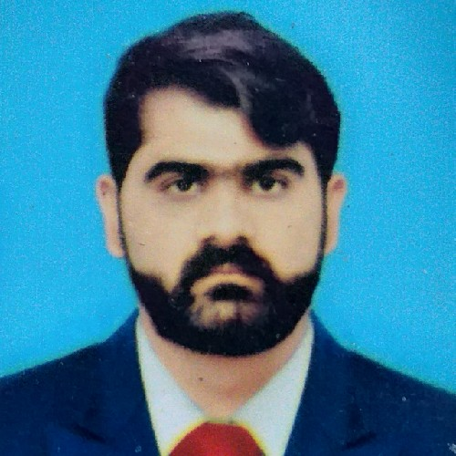**MUHAMMAD USMAN JAVED**

## CONTACT NO. +92-302-5620038

## EMAIL: mani.raja33@yahoo.com

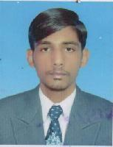**PERSONAL DATA**

Name :Muhammad Usman Javed

Father Name :Muhammad Javed Iqbal

Date of Birth : 26-06-1996

Nationality : Pakistani

N.I.C. NO : 37301-1098684-7

Religion : Muslim

Marital Status : Single

Personal Address : Malakwal, District Mandi Bahuddin

# LANGUAGES KNOWN

## English

* **Urdu**
* **Punjabi**

**ACDEMIC QUALIFICATION**

* **Matric (Science)**

(Usman Science School Malakwal, Dist., Mandi Bahuddin

BISE Gujranwala) Session – 2013

## DAE (Civil Technology)

(Hira College Sargodha PBTE Lahore) Session –2017

## BA

(AIOU Islamabad) Session –2020

# COMPUTER SKILLS:

## MS Excel

* + **MS Word**
  + **MS PowerPoint**
  + **Internet**

**OTHER SKILLS**

* Very Good At Achieving Targets In Tough Conditions
* Problem solving and decision making skills
* Service orientation and excellent organizational skills
* Can Work Late Hours And With Desired Dedication To Achieve Maximum Results In Least
* Active listening and effective communication competencies

**WORK EXPERIENCE**

* **Shaheen PSO Pump**

Duration: Feb 2021 to June 2024 Designation: Fuel station supervisor

Area : Old Airport Rawalpindi

* LCI Soda Ash company

Duration : Aug 2020 to jan-2021 Designation : Safety officer

Area : Kherwa