J it

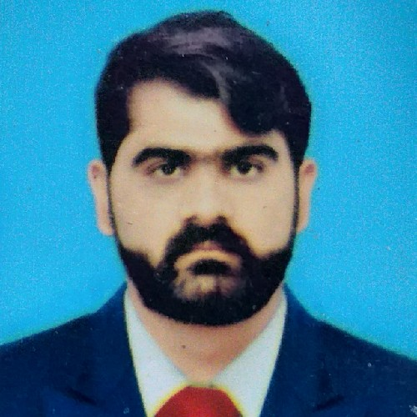**MUHAMMAD USMAN JAVED**

## CONTACT NO. +92-302-5620038

## EMAIL:rajamuhammadusmanjaved@gmail.com

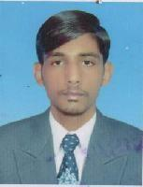**PERSONAL DATA**

Name : Muhammad Usman Javed

Father Name : Muhammad Javed Iqbal

Date of Birth : 26-06-1996

Nationality : Pakistani

N.I.C. NO : 37301-1098684-7

Religion : Muslim

Marital Status : Single

Permanent Address: Malakwal, District Mandi Bahuddin

# LANGUAGES KNOWN

## English

* **Urdu**
* **Punjabi**

**ACDEMIC QUALIFICATION**

* **Matric (Science)**

(Usman Science School Malakwal, Dist., Mandi Bahuddin

BISE Gujranwala) Session – 2013

## DAE (Civil Technology)

(Hira College Sargodha PBTE Lahore) Session –2017

# COMPUTER SKILLS:

## MS Excel

* + **MS Word**
  + **MS PowerPoint**
  + **Internet**

**OTHER SKILLS**

* Very Good At Achieving Targets In Tough Conditions
* Problem solving and decision making skills
* Service orientation and excellent organizational skills
* Can Work Late Hours And With Desired Dedication To Achieve Maximum Results In Least
* Active listening and effective communication competencies

**WORK EXPERIENCE**

* **Abacus Consulting Pvt. Ltd.**

Duration : Feb-2021 to Dec-2023 Designation : Customer Relation Officer

Area : I9/3, Islamabad

Project : Careem Cab Service

* **Shah Hussain Computer Shop**

Duration : Aug 2020 to Jan-2021 Designation : Data Entry Operator

Area : Malakwal, Distt. Mandi Bahuddin

* **United Construction Pvt. Ltd.**

Duration :Jan-2019 to May-2020 Designation :Foreman

Area : Askari I&IV, Rawalpindi