RIZWAN ULLAH

KHAN

CURRICULUM VITAE

**Father Name:**

**Abdullah Khan**

**CNIC No:**

**54303-3660875-3**

**Date of Birth:**

**21-08-1999**

**Marital Status:**

**UN-Married**

**CONTACT**

**Permanent Address:**

Killi Alizai, District Pishin

**Current Address:**

Ptcl Exchange Colony Flat No F-1. District PISHIN.

**Phone:**

0303-2162122 - 0313-8682570

**Email:**

[rizwann341@gmail.com](mailto:Rizwann341@gmail.com)

**LANGUAGE**

Urdu

English

Pashto

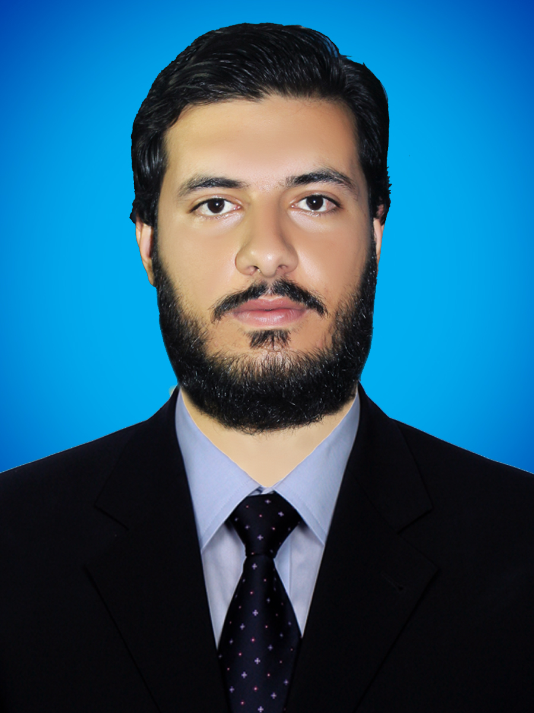

**SUMMARY**

Sincere, enthusiastic and loyal to the intentions and obligated duties.

**SKILL HIGHLIGHTS**

|  |  |
| --- | --- |
| * Public dealing * Management of company * Mentoring * Computer skills * Communication skills | * Project Management * Strong decision maker * Service-focused * Scouting |

**EXPERIANCE**

* 4 Years Experience as Area Supervisor with CTC on polio Eradication program
* 6 Months worked with BRSP as Enumerator.
* Worked with World Human rights protection.
* Typing of Urdu and English.
* One year as private Teacher.

**EDUCATION**

Matric Science, Grade-A: BBISE Quetta

Intermediate Pr-Engineering, Grade-A: BBISE Quetta

Bachelor of Arts: Division-1st University of Balochistan

Master of Arts: Division-1st University of Balochistan

**CERTIFICATION**

Basic IT: Rehman COMPUTER CENTER PISHIN.

English Language program: INSTITUTE FOR PROMOTING ENGLISH Pishin.

UNICEF CERTIFICATE.

BRSP CERTIFICATES .