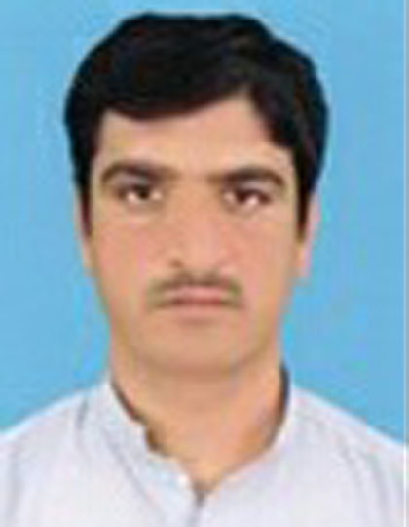

*Present Address:* Kotka Master Mandan Amin Mughal Khel P/O Almarkiz

Islami Ghoriwala Bannu.

E-mail ID: [Romankpkbanu@gmail.com](mailto:Romankpkbanu@gmail.com)

Cell NO: 0334-8817147,# 03339539604

**PERSONAL STATEMENT:** I am a confident and enthusiastic person with the ability to learn and adapt quickly to new challenges and to handle difficult situation under pressure. I have an organized approach with good communication skills, which enables me to work effectively either on my own or as a part of the team.

**EDUCATION: Master in social science**

|  |  |  |  |  |
| --- | --- | --- | --- | --- |
| **DEGREE** | Subject | BOARD/UNIVRSTY | | Obtaine marks/total marks |
| **SSC** | **Science** | | BISE Bannu | 459/850 |
| **F.A** | **Arts** | | **BISE Bannu** | **631/1100** |
| **B.A** | **Political Science** | | **USTB Bannu** | **254/550** |
| **M.A** | **Political science** | | **USTB Bannu** | **1052/1800** |
| **CT** | **Arts** | | **AIOU Islamabad** | **598/900** |
| **D.I.T** | **Computer** | | **BTE Peshawar** | **1141/1400** |

**WORK EXPERIENCE: 4 years in NGOs**

1. **2 months** Experience as a Field supervisor with **IRS Peshawar**. (Survey Project) Tablat base (MICS)
2. **LLIN Registration survey** with **SRSP** Bannu as a Enumerater Household deta collection survey (Tablat based)
3. **2 years** experience in teaching
4. Worked with **Al-Khidmat foundation Bannu**
5. **1 year** Experience in **BEFARe (** Education project.)
6. **2 years** Experience as a Community Outreach Worker with **Relief** **Pakistan**, (Nutrition project)(CMAM)
7. 09 months Experience as a (COW) with **prime foundation** Bannu, (MCDs)
8. **1year** Experience as a social organizer with **CARE**
9. **LLIN distribution** project with **Pakistan Read Crescent society (PRCS)** Bannu as a Distribution point supervisor
10. 3 years Experience with **Apex consulting Pakistan** as a Area Field supervisor (Polio Monitoring LQAS) Household deta collection
11. **FROM 2021 UpTo Date** **GCSS** Facilitator Experience with

**RIZ** **Consulting Pakistan**

**COMPUTER SKILLS:**

* Full Command over Microsoft Office (Word, Excel, Power Point), and Internet**.**
* Inpage
* OS

**LANGUAGES:**

* English (speaking, reading, & writing)
* Urdu (speaking, reading, & writing)
* Pashto (speaking, reading, & writing)

PERSONAL INFORMATION:

* Fathers Name: Muhammad Subhan
* Date of Birth: March 11, 1988.
* Permanent Address: Kotka Master Mandan Amin Mughal Khel P/O

Almarkiz Islami.

UNION COUNCIL shamshi khel

* Marital Status: Married
* Gender Male
* NIC NO: 11101-3278324-5

HOPEFULNESS:

Looking forward that I will be afforded an opportunity for an interview and selection is left to your own discretion.

**INTEREST:**

Work with people; help the people, and promulgation of a company.

Reference :

ZFM & Trainer: Zain ul Abedin, 03315910044

PM .relief Pakistan: 03335795051,03459333599