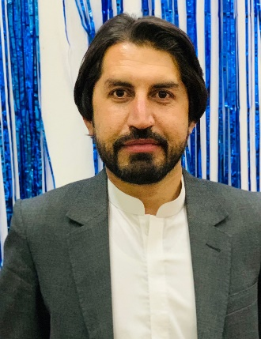**Saeed Ahmed**  Address: Pashtun Bagh Quetta

Contact Number: +92-333-2034533

E-mail: Saeedkhan0719@gmail.com

## **OBJECTIVE:**

Seeking a challenging and responsible position, where my experience and expertise may be fully utilized to achieve the desired organization objectives.

## **CAREER PROFILE:**

* Detail-oriented, efficient and organized professional with good experience in writing.
* Possess strong analytical and problems solving skills, with the ability to make well thought out decisions.
* Excellent written and verbal communication skills.
* Highly trustworthy, discreet and ethical.
* Resourceful in the completion of projects, effective at multi-tasking.

## **EDUCATION**

|  |  |  |  |  |
| --- | --- | --- | --- | --- |
| **Program/Degree** | **Board/University** | **Passing Year** | **Marks %** | **Major Subjects** |
| B.S (Mass Communication) | BUITEMS | 2018 | 2.96/4 (73%  CGPA) | Journalism |
| FSc. (Pre-Enginering) | B.I.S.E Quetta | 2013 | 62% | Pre-Engineering |
| Matriculation | B.I.S.E Quetta | 2010 | 63% | Science |

## **AWARDS, ACHIEVEMENTS & SKILLS**

* Event Organizer at BUITEMS.
* Cultural Secretary at Mass Communication Society.
* Worked on 4th and 5th Oxford Literature Festival Islamabad.
* Senior Chief Coordinator Islamic Blood Donors’ Society (IBDS).
* Proactive with energy to achieve Organizational targets
* Have Pleasant and Presentable personality
* Effective verbal and written communication skills.

## **DIPLOMAS, TRAININGS, WORKSHOPS & SEMINARS ATTENDED:**

* Worked with “SDPI” 1.5month
* Worked as a Line Lister and Data Collector in Post “Measles Rubella campaign coverage” survey(PCCS)Pakistan under WHO for 5 months
* Worked with “Individual Land” (NGO) for 5 Months
* Attendended Media Literacy session under “Individual Land” at BUITEMS
* A Member Green Squad Team Quetta
* SEMINAR ON " FIRE AND SAFETY DEMONSTRATION"

Organized by "Youth Optimistic Organization" INTERNATIONAL ISLAMIC UNIVERSITY ISLAMABAD

Held on: 4th and 5th of December 2013

* ONE DAY WORKSHOP " A DAY OF HUNDRED HOURS"

Organized by "Roshan Pakistan"

Held on: 22th February 2016

## **INTERESTS:**

Reporting, Content Writing, Project Management, Creative Writing, Article Writing, Critical Writing.

## **RESEARCH PROJECTS:**

* Critical analysis of misrepresentation of minor identities in Pakistan by media

## **COMPUTER SKILLS:**

Microsoft Word, Excel, Access, PowerPoint, Outlook Express, Microsoft Windows XP and Microsoft Office XP Professional, Internet searching.

## **PROFICIENCY IN LANGUAGES:**

English, Urdu & local Languages

## **HOBBIES:**

* Playing sports (Cricket, badminton), net surfacing, and listening to music.
* Playing cards, reading books & newspapers.

## **TEACHING EXPERIENCE:**

* Three-year experience in Multi National company as a supervisor.
* One year work experience as a lecturer in college.