Safeena Mengal

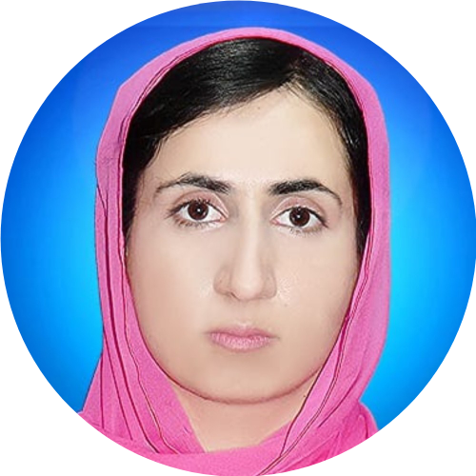

Doctor

# PERSONAL INFO

ID CARD 5410249724108

DATE OF BIRTH 25/10/1996

NATIONALITY

Pakistani

GENDER

Female

MARITAL STATUS

Single

EMAIL

# OBJECTIVE

Seeking my role to contribute to the prevention and control of vaccine preventable diseases, promoting health and well being in the community.

# EMPLOYMENT HISTORY

Lady Medical Officer

**HOUSE JOB**

APRIL 2023 TO APRIL 2024

Lady Medical Officer

BHCIP (A project of World Bank)

Mar 2024 - Ongoing

**Location:** Chaghi

Provided primary health care services including diagnosis, treatment and prevention of diseases.

# EDUCATION

## Government Girls High school Nushki

Aug 2009 - Jun 2011

[mengalsafeena@gmail.com](mailto:mengalsafeena@gmail.com) PHONE NO

03322084484

Matric CGPA/Percentage

## Government girls higher secondary school warah

68.95%

ADDRESS

Killi Qazi abad Nushki

# SKILLS

Strong clinical and communication skills

Knowledge of epidemiology, surveillance and public health principles

Excellent teamwork and leadership skills

Fsc Jul 2011 - Sep 2013

CGPA/Percentage 79.27%

## Bolan Medical College Quetta

MBBS May 2017 - Mar 2023

CGPA/Percentage 61.56%

# INTEREST

**Immunization Program Management & Evaluation:**

Epidemiology and disease surveillance community outreach and health education