SAFEER ULLAH
TPO Tank
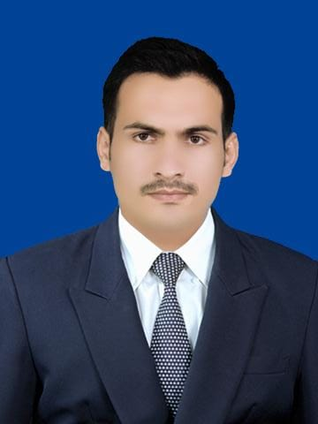  PERSONAL DATA  Father Name: Yaqoob khan  Date of Birth: 01.04.1991  C.N.I.C No: 12201-6122292-3  Domicile: FATA  Nationality: Pakistan  Status: Married  Address: Insaf traders inside gulapee opposite UBL Bank Tank City.  Cell: +92-3331116716 +92-3454417577  Email: safburki@gmail.com  Imsafeer23@yohoo.com  COMPUTER PROFICIENCY  - Excellent at using Office Suit (Microsoft Word, Excel, and PowerPoint).  - Experience with Tableau software.  PROFILE  ◊ Good communication skills.  ◊ Strong & coordinated team skills.  ◊ Energetic and hard working.  ◊ Strong sense of responsibility  HOBBIES & ACTIVITIES  ◊ Reading  ◊ Traveling & Cooking  ◊ Football  REFERENCES  ◊ DR. Tahir khan  District Coordinator WHO District Tank, DEOC DC Office Tank KPK Pakistan.  Cell No: +92-3431316161  Email: khanta@who.int  ◊ DR. Musa  IO WHO Tank  Office of the Deputy Commissioner, District Tank.  Cell No: +92-344-9293525  Email: muskhan@who.int | PROFESSIONAL EXPERIENCe
 | 04.2021- Present  01.2015 –  03.2021  07.2014 –01.2015  2017  2016  2014  2011  2009  2007  Achievements:  LINGUISTIC SKILLS | TEHSIL POLIO Officer District Tank: CTC (World Health Organization)  Duties /Responsibilities as TPO Tank  → Monitoring & Supervision:  - Coordination and Leadership at tehsil level.  - Supplemental Polio Vaccination Campaigns (SIA) supported at your tehsil level and daily issues discussed in evening meeting.  - AFP Surveillance under supervision of DSO and IO at your district  - Routine Immunization.  - Implement any additional tasks and/or activities related to polio eradication assigned by the supervisor.  UNION COUNCIL POLIO OFFICER, CITY2 DISTRICT TANK  Organization: CTC (WORLD HEALTH ORGANIZATION)  Duties /Responsibilities as UCPO  → Monitoring & Supervision:  - Preparation of Micro plan, Mapping & identifying high risk areas.  - Selection appropriate team & supervisors as per criteria and their distribution as per need.  - Assist PEO in planning, coordinating & organizing training sessions for team and supervisors.  - Promote partnership and coordination with all influencing factors in support of SIAs.  - Monitor and supervise the process of implementation of the campaign as per guideline.  - Data collection and analysis from the area of responsibility on daily basis  - Ensure proper implementation with special attention to hard-to-reach areas & under-served high risk population. Facilitate the work of independent monitors.  Customer Service Representative Lahore Organization: Digitech Outsourcing Solutions  → Duties /Responsibilities as CSR  - Answering customer's emails via Kayako Ticketing System.  - Maintaining defined service level (24 hrs response time)  - Checking membership and licenses in system  - Troubleshooting basic word press and plugin issues  - Escalating programming errors to tech department  - Communicating with team (US and Canada based) via skype  - Attending team meetings.  EDUCATION  Allama Iqbal Open University, Islamabad  Certificate of Teaching  KPK Board of Technical Education  Diploma in information Technology  University of Management and Technology (UMT), Lahore  M.COM (specialization in Finance)  University of the Punjab, Lahore  B. Com  PIMCS college, Lahore  I.COM  Government WENSAM College D.I.khan  Matriculation  - Appreciation Certificate from Provincial Polio Eradication Officer (WHO-KPK) Dr Israr Ul Haq, Area coordinator (WHO-DIKhan Division) Dr Adnan Akbar khan and PEO (WHO-DIkhan/Tank) Dr Afazal Rehman for best performance in Polio eradication at UC level in 2015  - Appreciation certificate awarded by Fahad wazir DC Tank and DHO Tank for dedication and effective work at UC level in 2018.  - Appreciation Certificate awarded by DC Tank Kabir Afridi on account of good performance in June campaign 2021 and ceremony was taken place DC Office Tank.
  ENGLISH  URDU  PUSHTO | Speak: Excellent  Speak: Excellent  Speak: Excellent | Write: Excellent  Write: Excellent  Write: Excellent

