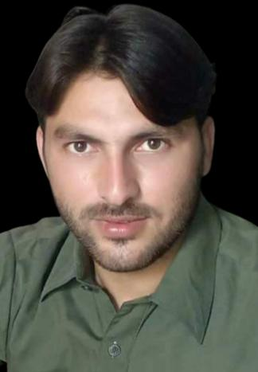

**SAFEER ULLAH**

# **Permanent Address:**

Kirri Haider P/O Tank kirri Haider

Tehsil & District TanK

**Mob:** +92-349-9285670

# **Personal Information:**

Father Name Fida Muhammad

Date of Birth 01-01-1999

C.N.I.C 12201-0316330-7

Gender Male

Domicile FR Tank

Nationality Pakistani

Religion Islam

Marital Status Un-Married

# **Academic Qualification:**

|  |  |  |  |
| --- | --- | --- | --- |
| DEGREE | **YEAR** | **MARKS** | **BOARD/UNIVERSITY** |
| S.S.C | 2015 | 781/1100 | B.I.S.E D.I.KHAN |
| F.Sc(Pre-Medical) | 2017 | 695/1100 | B.I.S.E D.I.KHAN |
| B.Sc | 2019 | 336/550 | Gomal University D.I.Khan |
| M.Sc (Botony) | 2023 | CGPA (2.98/4.00) | Gomal University D.I.Khan |
| D.I.T | 2020 | 1061/1400 | BTE Peshawar |

# **Experience;**

01-Year Experience in MS Word, MS Excel,

01-Year experience as a sales officer ABBOT Pharmaceutical Company Dera Ismail Khan

# **Language Skill;**

English Urdu Pashto

# 