Address: Sahib Zada Stationary Near Town  **CONTACT INFORMATION**



Hall Shopping Center .D.I.Khan

Cell No. 03169584180/03345502595

**SAJID ULLAH**

# CAREER OBJECTIVE

To work in an environment where appreciation and satisfaction furnishes my skills and progress of the corporate values my appreciation. The company’s objective is my objective. Flexibility of adopting different environment uplifts me to take any new challenges.

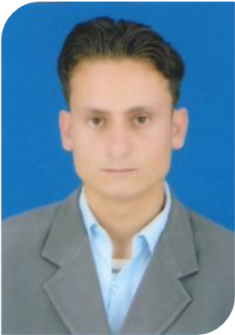

|  |  |  |  |
| --- | --- | --- | --- |
| **PERSONAL** INFORMATION**:** | | |  |
| Father’s Name | : Aekhbar Ullah | |  |
| Date of Birth | : March: 05 ,1994 | |  |
| Nationality | : Pakistani | |  |
| Marital status | : Un-Married | |  |
| Cell No. | : 0345-9832364 | |  |
| NIC. | : 21704-6005790-9 | |  |
| Domicile | : S.W.A | |  |
| **ACADEMIC QUALIFICATION:** | | |  |
| **S.S.C** (2009) | | 703/1050 | B.I.S.E D.I.Khan |
| **F.Sc** (2011) | | 633/1100 | B.I.S.E,D.I.Khan |
| **B.A**  (2011-12) | | 247/550 | Gomal University D.I.Khan |
| **C.T**  (2014) | | Complete | AIOU Islamabad |
| **M.A (English)** 2016 | | 872/1700 | Gomal University DIKhan |
| **B.Ed** (2015) | | 614/900 | Aiou islamadad |
| **EXPERIENCE:** | |  |  |

1 year Experience with SRSP as social organizer . Wash project

1. Years Experience with Apex Consulting Pakistan as area Field officer in LQAS project.
2. Years Teaching Experience in Muhib Children Academy.

9 months Experience with Women empowerment organization as a social organizer

1 year experience with Apex as data collector (enumerator) in LQAS Project

10 months experience with WHO (World Health Organization) as surveyor in LQAS project.

2 months experience in TPVICS ( trust for vaccine and immunization) as data collector and linelister.

# COMPUTER SKILL

 3 Months short I.T Course from Hamd Group of Education System D.I.Khan.

# SPORTS

 Hand Ball, Volley Ball and Tug of War Player certified by Qurtuba School & Collage.

**LANGUAGES:**

English Urdu Pashto