RESUME

Name  Contact #  Whatsapp #  Email address | 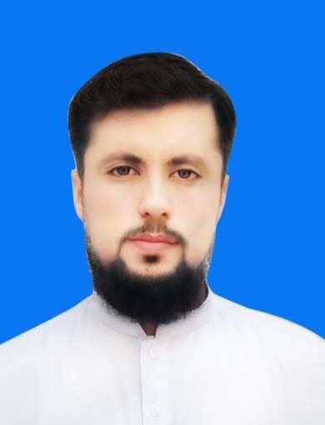 SAJJAD RAIS KHAN  0305.9995251  0343.9265251  sajjadraiskhan143@gmail.com
Father name | Rais khan
Date of birth | 28/03/2001
Gender | Male
Domicile | Lakki marwat
N.I.C.# | 11201-7818942-3
Nationality | Pakistani
Religion | Islam
Marital status | Single
Permanent address | Village Toor lawang Khel, Distric lakki marwat
Personal | Department of Zoology  The University of Lakki Marwat.
Highest Degree/ Qualification | Graduate. (16 years of education) in Zoology
Bachelor of science:16 years | . Degree : BS (Honor) in zoology  . CGPA : 3.47/4 (86.75%)  . Institute : The university of Lakki Marwat
Higher Secondary School Certificate | . Certificate : F.Sc (pre-medical)  . Grade : 825/1100 (75%)  . Session : 2018  . Institute : B.I.S.E Bannu
Secondary School certificate | Certificate : SSC(Science)  . Grade : 959/1100 (87.18%)  . Session : 2016  . Institute : B.I.S.E Bannu
Diploma in Information Technology | .Certificate : DIT  . Grade : 1091/1400 (77.92%)  . Session : 2020  . Institute : PPC Inter College Bannu
Computer skill | . M.S word  . Microsoft excel  . English typing  . Audio & video

