### **Curriculum Vitae**

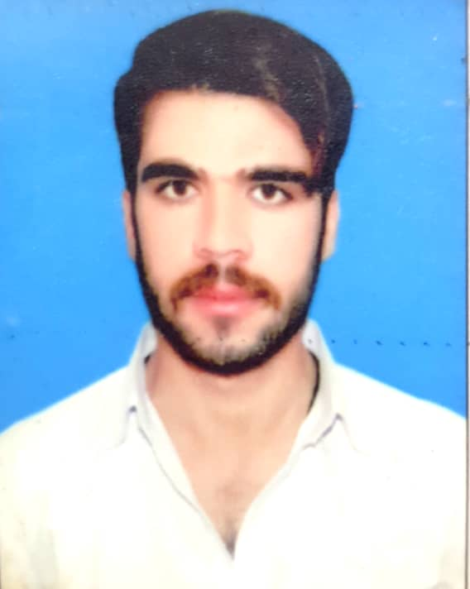

***SAKHI DOST***

**Address: Saryab Mill Colony Quetta**

**Phone No: 0331-8040816**

**OBJECTIVES**

***Looking forward to be a part of a dynamic organization where results are rewarded, and can work for the community development sector through my***

**PERSONAL INFORMATION**

**Father’s Name: Hakim ali**

**Local: Dera Bugti**

**Date of Birth: 25-02-2002**

**Gender: Male**

**Marital Status: Married**

**ACADMIC QUILIFICATION**

|  |  |  |  |
| --- | --- | --- | --- |
| **Degree Name** | **Year** | **DIVISION /CGPA** | **Name of Institution** |
| Matric | 2018 | 2nd Division | BBISE QUETTA |
| Fsc | 2021 | 1st Division | BBISE QUETTA |
| D.A.E | 2023 | 1st Division | BBISE QUETTA |

**EXPERIENCE:**

**03 Year Experience As Side Engineer**

**2 months Experience As a rider Trax Company**

**Basic computer skills internet browsing**

**LANGUAGE SKILL**

Urdu, Balochi, Brahvi, Sindhi English Pashto