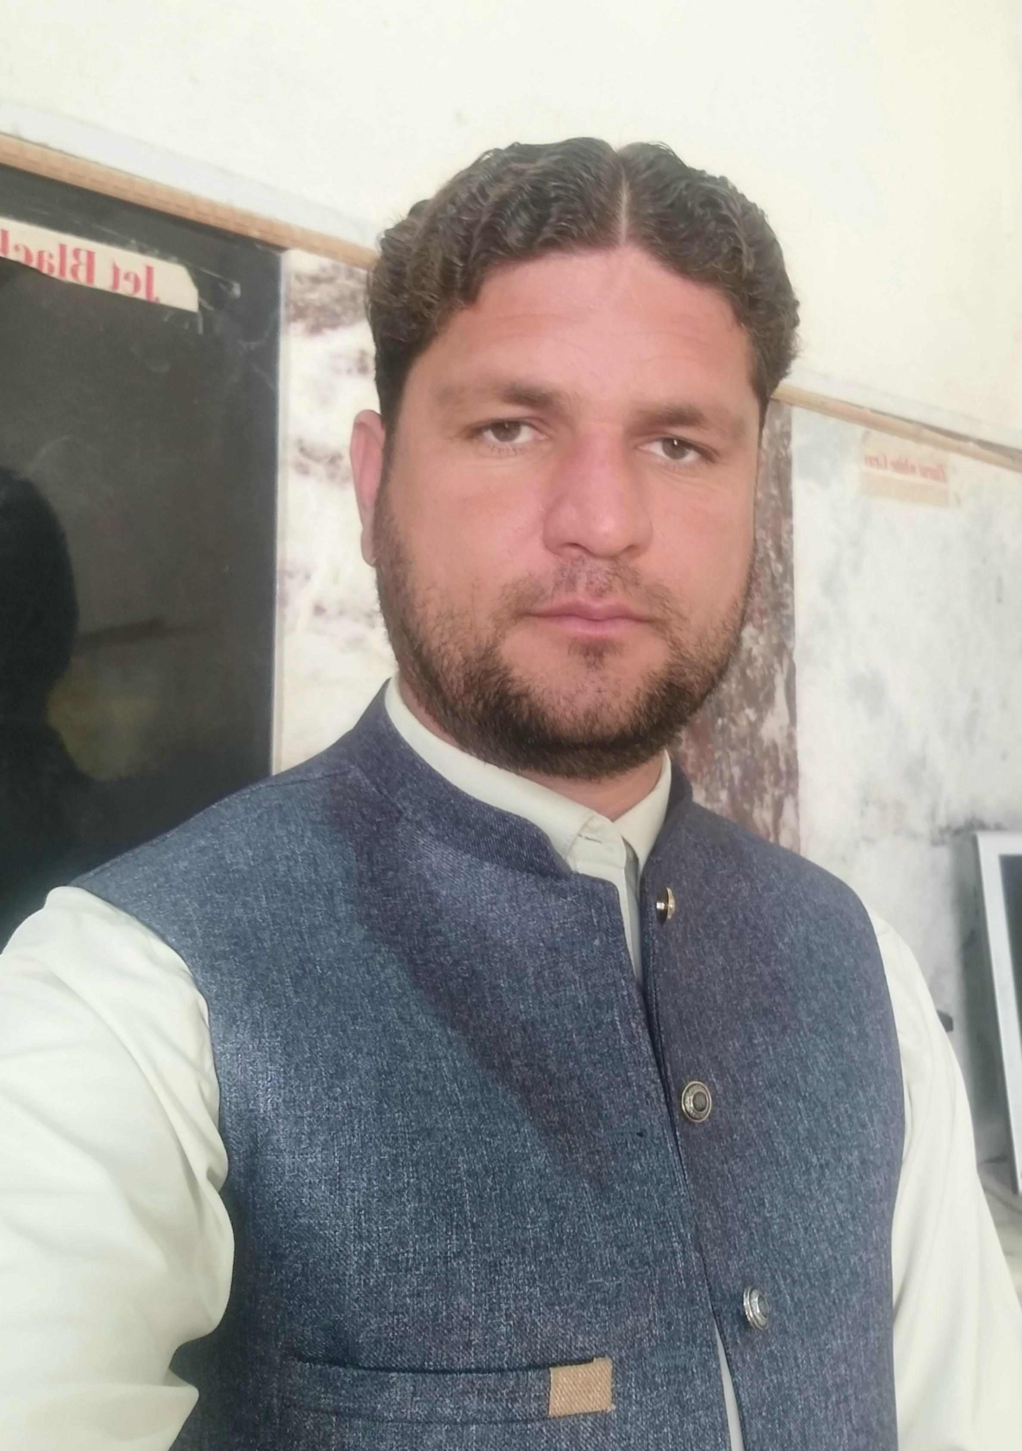SAMI ULLAH

Union Council Communication Officer (UCCO)

Objective

I am young and energetic having pleasant personality with strong interpersonal Communication skills, self-motivated and responsible professional appearance. Task oriented, flexible adoptable and love to work in challenging environment. More than 8 years of field experience gives me an opportunity to work in different communities.

**Personal Information:**

***Address***: ***Village Bhai Khan Kalay, P/O Paindi Lalma, Tehsil Jamrud (Mullagori), District Khyber.***

***Union Council: Paindi Lalma Mullagori.***

**Cell: 0313 9944766**

**E-mail**: [**Farhansami66@gmail.com**](mailto:Farhansami66@gmail.com)

**CNIC No**: 21204-8437108-9

**Father Name**: Asmat Khan

DOMICILE : District KHYBER ( Mullagori )

## QUALIFICATIONS*:*

|  |  |  |  |
| --- | --- | --- | --- |
| ***Degree Title*** | ***Passing Year*** | ***Duration*** | ***Board/ University*** |
| ***MSc (Economics)*** | ***2015*** | ***2 Years*** | ***Peshawar University*** |
| ***B.Sc. (Comp Science)***  ***B.Ed*** | ***2010***  ***2017*** | ***2 Years***  ***1 Year*** | ***Peshawar University***  ***Peshawar University*** |
| ***F.Sc*** | ***2007*** | ***2 Years*** | ***BISE Peshawar*** |
| ***S.S.C(Science)***  ***DIT*** | ***2005***  ***2012*** | ***2 Years***  ***1 Year*** | ***BISE Peshawar***  ***Peshawar Technical Board*** |

**Professional skills**

* Proven leadership and human management skills
* **Strong Communication and Advocacy Skills**
* Strong Presentation skills
* Monitoring and evaluation skills
* Time-efficient, systematic working methodology
* Rapid adaptability to new problem-solving and new locations
* Data collection ( forms filling )
* Strong confidence to make public presentations and communicate with authority figures.
* Creativity and flexibility to adapt to the different social groups
* Political, religious and cultural sensitivity

***PROFESSIONAL EXPERIENCE***

1. ***People ( Professional Employers Pvt Ltd )***

* ***Post Name: Union Council Communication Officer ( UCCO )***
* ***Organization: People***
* ***Duration: Continue till date***
* ***Location: Paindi Lalma Mullagori***

**Responsibility :**

* Develop and maintain relationships with community stakeholders including local leaders, health workers, political Leader etc and community based Organization.
* Work with community members to identify and address barriers to Immunization uptake including misconception about vaccine.
* Planning and organizing community mobilization activities such as community meetings, door to door visits community out reach events.
* Mobilizing and engaging community members to increase their knowledge and understanding of Immunization program.
* Monitor and report on community engagement activities and outcomes inform program planning and decision making.
* Participation in training and capacity building activities to improve knowledge and skills related to community mobilization and Immunization program.

1. **NASRULLAH JAN INAMULLAH KHAN & COMPANY (PVT) LTD.**

(April 2009-January 2012)

* **Job Title :**  **Computer Operator**
* **Job profile:**
* Typing, Documentation Skills.
* General, Scheduling.
* Written Communication.
* Administrative Writing Skills.
* Attention to Detail.
* Uses a personal computer and a variety of office software applications including word processing, Email, and file management.
* Creates or maintains files in Excel. May create PowerPoint presentations and use Access or other databases.
* Operates other office equipment such as printers, copy machines, fax machines. May serve as liaison with service and vendor personnel.

1. **CTC ( Chip Training and Consulting )**

* Post name: Area Supervisor
* Organization: CTC (Khyber)
* From : August 2015 to February 2018
* Location: Paindi Lalma Mullagori

**Responsibility:**

* Documentation and Report Writing.
* Micro plan Preparation
* Supportive Supervision
* Monitoring of teams
* Desk and Field Validation
* Pre Campaign Team training
* Problem Solving.
* Analyze Data

# WHO ( World Health Organization).

* Project Name: EPI (Expended Program on Immunization)
* Duration: January 2015 to August 2015
* Post Name: T.T.M ( Temporary Tehsil Monitor)
* Location: Paindi Lalma Mullagori

**Responsibility:**

* Team Monitoring
* Desk validation
* Micro plan validation
* Team training monitoring
* House to house cluster
* Field validation.

***Trainings***

**Leadership Management Skills Training (LMST)**

**Training centre: Pakistan Academy For Rural Development Peshawar.**

From **December 02-06,2013**

## LANGUAGES

* Fluent in English, Urdu, and Pashto and local languages

**References**

1. **Nisar Khan**

**Designation: Tehsil Delivery and Operation officer.**

**Phone:** 0300-9066134

**Email:** [**nisarkhan54mgi@gmail.com**](mailto:nisarkhan54mgi@gmail.com)

1. **Said Afzal**

**Designation: Tehsil Communication Officer ( TCO ).**

**Phone: 03317995533**