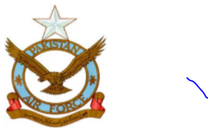

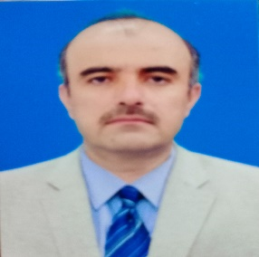

**SAMI ULLAH SHAH**

**Professional Summary:**

An experience professional and competent, reliable technical, administrative setup Manager, with 25 years proven track record of providing specialist managerial support to PAF. Extensive knowledge and practical experience of working at Logistics management setups with Support Wing, Engineering Wing, Flying Squadron and Air Headquarters, Islamabad. Gifted with outstanding traits of initiatives, sharp comprehension and absolute confidence in abilities. Potential to perform all types of administrative, managerial assignments and contingencies efficiently. Possesses sound experience of planning, conduct and execution of evaluation related activities. Extremely capable with Data Analysis, Configuration Management, Office Management, Logistics management system (palms) enterprise version, Ware housing, indenting / contract management and repair / purchase management which includes formulation and implementation of policies, accurate forecasting and procurement of Aircraft, Stationary, Clothing and MT components.Has vast experience of office management, administration, evaluation and supervision.

**Objective:**

To pursue a progressive career in a dynamic organization which provides opportunities for both professional and personal growth and develop skills to expend the organization‘s performance and profitability.

**Personal information:**

**Father’s Name : Syed Bismillah**

**Date of Birth : 04 Feb, 1978**

**Date of Retirement (SOD) : 21 March, 2023**

**Rank on Retirement : Warrant Officer**

**Total Service : 24 Years 05 Months**

**CNIC No : 5440003400929**

**Nationality : Pakistani**

**Language Skill : Pashto, Urdu & English**

**Marital Status : Married**

**Religion : Islam**

**Present Address : Saifullah colony Pashtoon Dara Quetta**

**Permanent Address : Saifullah colony Pashtoon Dara Quetta**

**E-mail Adress : sameeshah273@gmail.com**

**Contact Number : 03212535831**

**Whats App : 03479930399**

**Educational Qualification:**

|  |  |  |
| --- | --- | --- |
| Matriculation | 1995 | Cadet College Mastung |
| FSC | 1997 | Cadet College Mastung |
| Certification in Logistics Management (Supply) | 2000 | School of Logistics, PAF Kohat |

**Professional Courses / Certifications:**

|  |  |  |
| --- | --- | --- |
| **S#** | **Certificate / Courses** | **Name of Board / Institute** |
|  | PAF Academic Training | PTTS, PAF Kohat |
|  | Diploma in Logistics Management and Procedures (Supply) | School of Logistics, PAF Kohat |
|  | SNCO Disciplinary Course | PAF Base, Samungali, Quetta |
|  | SEP Supervisor Management Course | PAF Base, Samungali, Quetta |
|  | Logistics Trade Portion Course (JCO) | PAF, School of Logistics, Kohat |
|  | Military Leadership Course (JCO ) | Air Headquarters, Islamabad |
|  | Certification as Administrator / Manager in Log and Supply Chain | Air Headquarters, Islamabad |
|  |  |  |

**Experience / Employment Record:**

|  |  |  |  |
| --- | --- | --- | --- |
| **S#** | **Organization / Employer Name** | **Job Title** | **Duration** |
|  | Engineering Wing, PAF Base Mushaf | Ware Housing / Store Supervisor / Inventory / Issue and Receipt / Office Management / Computer and File Work | 3 Years 6 Months |
|  | Flying Wing  PAF Base Samugali | NCO incharge Inventory Jet Store, Tech Store, Stationary and Clothing Stores / Office Management / Computer and File Work | 5 Years |
|  | Support Wing  PAF Base Samugali | Local Purchase and Repair of MT and Misc / POL Handling and Rubber Store Incharge / Office Management / Computer and File Work / Supervisor / Security Guard Commander / URF / QRF | 9 Years |
|  | Dte of Weapon System Management Mirage, Air Headquarters, Islamabad | Procurement Processing / Budget Management / Definitization / Repair and Purchase Management System / Rate Running Contracts and Financial Advisor. Computer Proficiency (Drafting of letters, Presentation making) / Administration | 4 Years 10 Months |

**References:**

References will be furnished as required