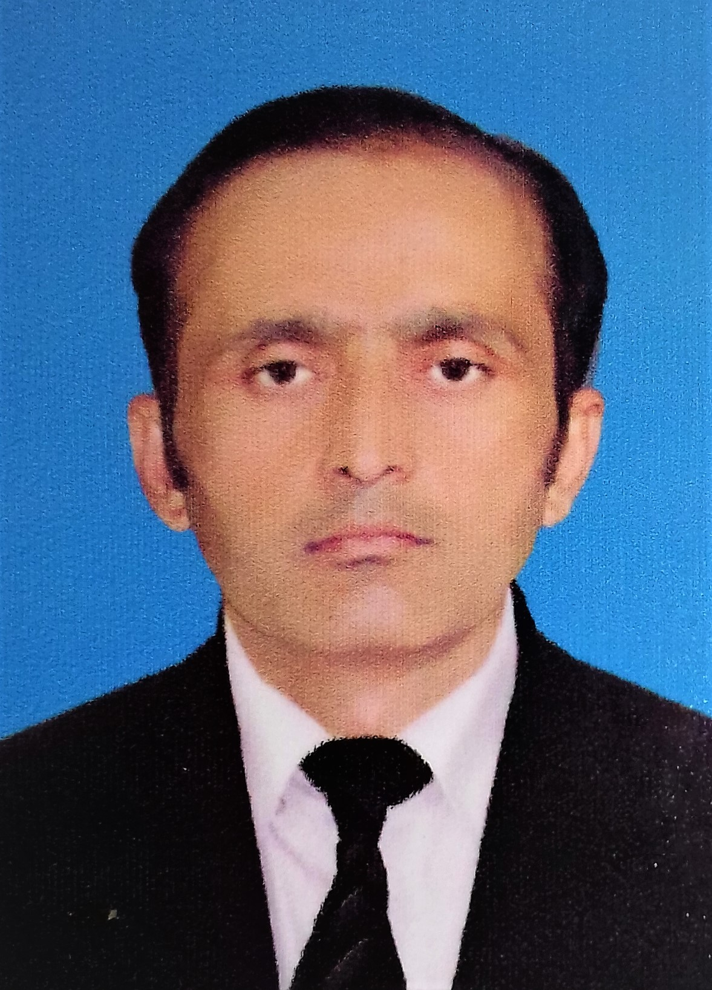HOUSE NO.140 paracha town, near madrisa, pindi road, KOHAT CITY.
khyber pakhtunkhwa, PAKISTAN
Cell#+92-3339627722
email: MSMSAQIBARIES@GMAIL.COM.

saqib mahmood

OBJECTIVES: | Ability to work in challengeable and multinational environment as per my qualification, experiences and expertise. Learn to know about diversifiable prospective of international arena for career accomplishments.
experience:  position: | OPERATIONS & accounts MANAGER |  |  |  | From:  01/03/2011  F |  | Current  To: 31.07.2013  Contract Closed
Organization:(I)  Responsibilities: | DPSC / District Disaster Management Unit For Kohat Region
- Analyze, Summarize and Visualize Data collected through various sources as well as collected from fields, to predict the required results and to share report with stakeholders and Donors on periodically basis.
- Actively perform warehouse operations.
- Planning for survey regarding flood affectees
- Monitoring and evaluation of survey teams.
- Collection of data regarding Citizen Damage compensation program from Watan Card Facilitation Centers of NADRA.
- Data Analysis, Data Mining, Data Visualization, using Software tool Power Bi and Python.
- Camp Management of Internally Displaced People (Food, Health, Shelter, Hygiene).
- Monitoring of survey, distribution, need and assessment of IDPs activities.
- Monitoring of District Review and Joint Committees regarding verification of damages of flood/ manmade disasters.
- Arrangements regarding pre/post disaster, necessary trainings, disaster risk reduction, camp management, evacuation centers, early warning systems, encroachment of debris and restoration of communication system.
- Payroll, Departmental budgeting (salary & non-salary), Social and Developmental Budgeting in response of pre/post disaster risk reduction.
- Financial Management and Budgeting regarding Disaster Projects.
- Financial Statements, departmental and Bank’s Reconciliation
- Monitoring and evaluation of NGOs/INGOs working in District.
- Planning regarding Monsoon Contingencies every year with all stakeholders as well as NGOs/INGOs working within the district authorities.
POSITION | MANAGER finance. |  |  | From: 10/08/2008 |  | To: 28/02/2011
Organization: (II) | Pakistan Red Crescent Society and International Committee of Red Cross joint relief operation for Bajur Agency/Swat/Malakand Division KPK, Pakistan.
Responsibilities: | - Management of IDPs Camp, monitoring and evaluation of different activities on daily basis as getting feedback from different section and report to Regional as well as head office in order to get action promptly.  - Maintaining of Accounts like Ledger, Cash Books, Reconciliation, Activities base Budgeting and Keep the financial record for feedback and monitoring and evaluations of the organization.  - Payment to Contractors, Vendors, Labors, Stipend payment to Volunteers, Field Staff Members and to Managerial Staff of PRCS.  - Keep the track record of advance working capital credit payments during the emergencies.  - Drawing and Disbursement, Budgeting, Meetings. Management of stocks of logistics and management of Medicines Stock. Report writing.  - Financial negotiation with donors during emergence in order to resolve the issues of external stakeholder timely.
position | accountant |  | From: 16/03/2004 |  |  | To: 12/06/2008
Organization: (III) | District Government KDA Sector 2 Kohat Pakistan
Responsibilities: | - Arrangements for District Budget preparation and estimation (revised, additional and final grants and utilizations).  - Audit matters and document preparation (Audit Para and replies and meetings) at District level. And necessary arrangements for District Accounts Committee and Provincial Accounts Committee.  - Hiring, Firing, Compensation, Pensions, Govt: Allowances and Disbursement of Employee’s Funds and creation of HR Data Base.  - Maintaining accounts books, Reconciliations, Preparation of official Budgets, Internal & External Audit  - Communication with external and internal higher bodies, public dealing.  - File keeping and record maintenance, Presentation and reports writing, Managerial work.  - Purchasing and maintenance of official equipment, meeting and minutes.
education: | MCS (Computer Science) 2018  MBA (Finance and Accounting)2008  B.COM 2004  D.COM 2000  S.S.C 1998 | Virtual University of Pakistan  Preston University, Kohat, Pakistan  University of Peshawar, Pakistan  B.T.E. Peshawar, Pakistan  B.I.S.E. Peshawar, Pakistan
computers SKILLS:  certifications |   Hardware, Software Applications (MS Office, Graphic Designing), Operating Systems, Web Design and Development, C++, Java, PHP, DBMS, SQL, Networking, Data Analytics, SEO Expert.  - IBM Data Science Professional Certificate.  - Google Analytics.
EXPERTISE /skills: | - Budgeting, Zero base budgeting, Incremental budgeting, and activity based budgeting, Analysis of chart of accounts, with cost centers, revising, estimating, and developing and non-developing budgeting system.  - Forecasting of cashflow on the basis of monthly, quarterly and annually. Master Budgeting with subsidiary / departmental budgeting.  - Maintaining of book of accounts i.e. Cashbook, Stock Registers, Internal /external reconciliation with bank. Purchasing and handling of assets.  - Project base budgeting on the basis of need of the project, objectives of the project, activities of the project, needy resources of the project, and allocation of funds for the organized project.  - Internal Auditing, SWOT Analysis, Setting of objectives by strategies formulations.  - Computing, with MS Office, Windows/DOS, Database, Graphics Designing, Animations, troubleshooting of computer tools, Assembling, maintenance and other hardware.
languages: | English: (Read, Write, Speak)  Urdu: (National)  Pashtu: (Read, Speak)  Hindko: (Native)  Panjabi: (Speak)
personal: | Saqib Mahmood S/o Umer Hayat  Date of Birth: 3rd April, 1982  NIC #: 14301-8829476-5  Passport No. HZ0154761  Domicile: Kohat  Nationality: Pakistani  Marital Status: Married  Sex: Male  Religion: Islam
****

