**PHONE: +92-333-9206143 EMAIL: saquib5@icloud.com ADDRESS:** Haji Tent Service, Chowk Gari Khana, I/o Lahori Gate

Saquib Altaf

Summary

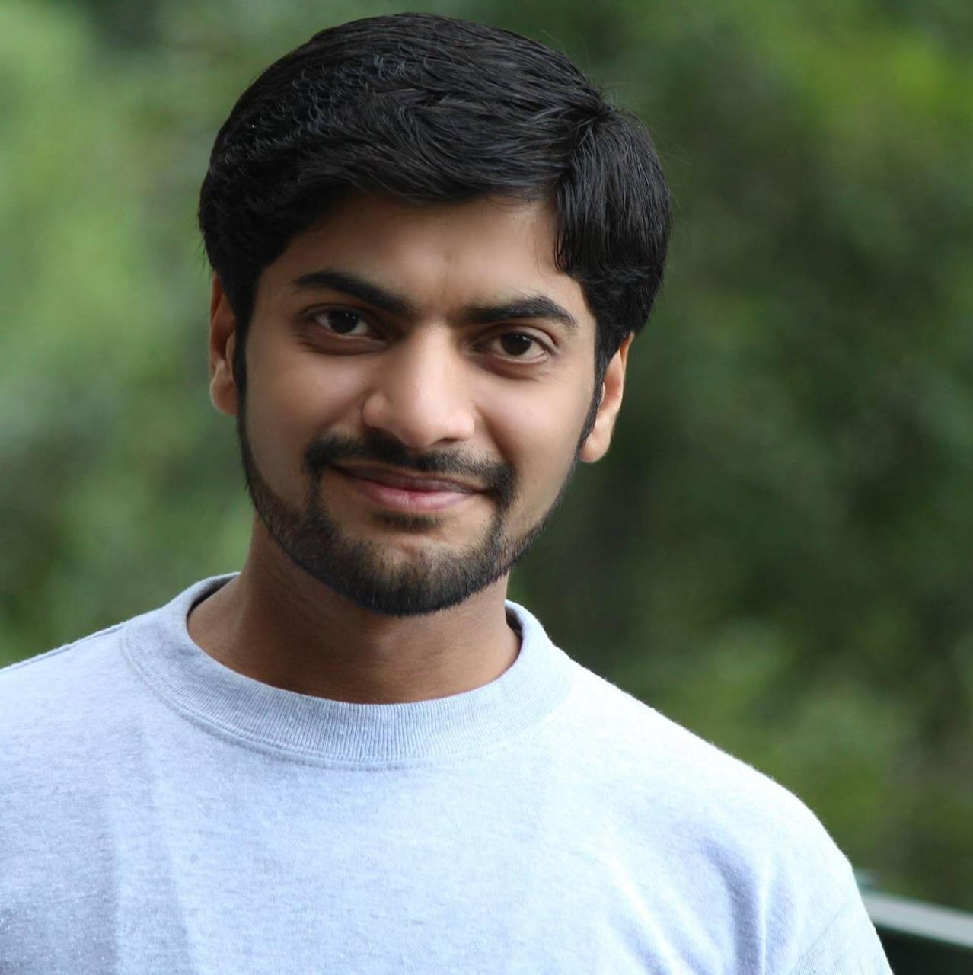

Address:

Haji Tent Service, Chwok Gari Khana, I/o Lahori Gate 25000Peshawar

Personal information:

E-mail: [saquib5@icloud.com](mailto:saquib5@icloud.com)

myvirgo786@gmail.com

Phone: +92-333-9206143

Marital status: Married

Wish to be in a dynamic organization where growth is interpreted in terms of not only monetary & career progression, but also upon the enhancement of mental & personal faculties. Wish to work in a learning environment in a way to polish & strengthen my professional skills.

Work experience

**BEFARe (NGO)**

***Senior M&E, MIS Officer***  
August-2021 - till date

* Development and tuning databases and related applications.
* Maintenance and up gradation of organization website.
* Network maintenance and all kind of troubleshooting.
* Designed the formats and procedures for operational monitoring
* Make field plans for the field officers and monitor their activities.

**BEFARe (NGO)**

***Translator/MIS officer***  
September-2016 - July-2019

**Project: Independent Monitoring Unit (IMU), A Project of USAID**

* Reading through original material and rewriting it in the target language, ensuring that the meaning of the source text is retained;
* Using specialist dictionaries, thesauruses and reference books to find the closest equivalents for terminology and words used;
* Writing Reports and Analysis/FGD reports.
* Transcript writing.
* Proofreading and editing final translated versions;
* Providing clients with a grammatically correct, well-expressed final version of the translated text, usually as a word-processed document.
* Using the internet and email as research tools throughout the translation process.
* Prioritizing work to meet deadlines.

**BEFARe (NGO)**

***MIS Officer***  
October-2013 - August-2016

* Development and tuning databases and related applications.
* Data entry in database for various project activities and its reports' generation.
* Provision of all statistical data for annual school results analysis reports.
* Analyzing school examination results and preparing graphs/charts for the results' analysis report.
* Data collection from field-by-field staff to generate various statistical reports.
* Assist in preparation presentations about project activities.

**City University of Science & Information Technology**

***Assistant to Students Services Officer***  
February-2011 - September-2013

* Worked as Assistant SSO (Students Services Officer)
* Coordination between students and faculty.
* Timetable setting and management through Software.
* Students Registration for various courses through Software.
* Organizing students Societies Election, Seminars, Tours.
* Resolving students related issue

Education

Abasyn University  
*MCS* 2013 – 2015

University of Peshawar  
*BCS* 2009 – 2010

GHSS No.4  
*Intermediate (Statistics Mathematics Economics)* 2006 – 2008

GHS No.2 Peshawar  
*Matriculation (Science Group)* 2004 - 2005

 Computer Skills

* Microsoft Office
* Outlook
* Networking
* CS Pro
* Troubleshooting

(*Typing Speed 35-40 WPM)*

 Achievements & Awards

* I remained Member of Character-Building Society in City University of Science & Information Technology.
* I have the honor to conduct society’s elections in City University of Science and Information Technology.
* During my stay at University, I organized several functions both as a student and as an employee e.g., Farewell, Welcome, Funfair, Tours, debate contest and many more.
* During my job at dell, I attend a training about communication skills and public dealing.
* During my stay at BEFARe I attend Monitoring & Evaluation training which was arranged by SDPI.

 Languages

|  |  |  |  |
| --- | --- | --- | --- |
| **LANGUAGE** | **READING** | **WRITING** | **SPEAKING** |
| **URDU** | Excellent | Excellent | Excellent |
| **ENGLISH** | Excellent | Excellent | Excellent |
| **PASHTO** | Good | Average | Excellent |
| **PUNJABI** | Good | Good | Excellent |
| **HINDKO** | Good | Good | Excellent |

 References:

**Zeeshan Altaf**

Designation: Territory Sales Manager

Company Name: DHL Pakistan Pvt Ltd.

Email: Zeeshan.altaf@dhl.com

Contact No: 0302-8710596

­­­

**Syed Mehdi Abbas**

Designation: Administrator

Company Name: Jung Groups

Email: [syed_mabbas@hotmail.com](mailto:syed_mabbas@hotmail.com)

Contact No: 0345-9094154