SAREED ULLAH

Father Name : Muhammad Farid Khan
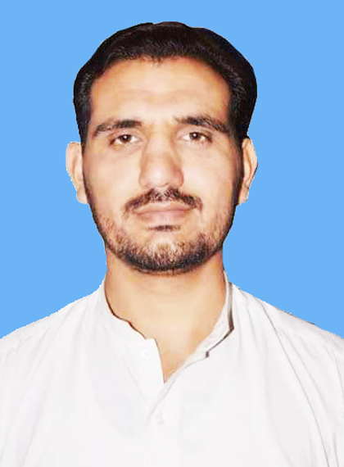
CNIC : 11101-4146281-9
Contact No : 0092 3044655288
Date of Birth : 03-01-1992
District : Bannu
Domicile : FR Bannu
Permanent Address: Vill: Bizan Khel, Post office Mattaki Bizan Khel,
Distt Bannu, K. P.K Pakistan./OR University Photostat Service Township
Bannu KPK Pakistan.
Email: sareedwazir@gmail.com

OBJECTIVES
To become a part of dynamic group where I can further explore the skills and Capabilities which I gained in the whole academic career; and to serve in a challenging work environment and to gain equally vast opportunities of career development based upon achievement and results.

EDUCATION
BS Electronics Hons(2011-2015) CGPA 2.9/4.0
- IT block of Electronics &computer Sciences GPGC ( University of Science & Technology Bannu, K.P.K, Pakistan)
F. Sc Pre-Engineering(2010) Marks: 56 % (611/1100)
- BISE Bannu, K.P.K, Pakistan
- Govt; Degree College S.K Bala Baanu
S.S.C General Science (2007) Marks: 61 % (549/900)
- BISE Bannu , K.P.K, Pakistan
- Govt; High Secondary School no2 Bannu

Final year project (controlling of home appliances through GSM)
I have completed my project which was biased upon GSM to control any electric component through GSM.

SKILLS & Experience
- From April 21 to till date with (PEOPLE ) as area level Social Mobilizer(ALSM).
- 1 year experience with CTC as ALSM.
- 1 year experience as supervisor and Assistant with Industrial Development Officer District Bannu. (NATION INTERNSHIP PROGRAM).
- Duration time. From 27 July 2016 to July 2017.
- Computer: Six Months Diploma from Dawn Computer Centre Karak Presentation
  - Communication
  - Problem Solving
  - Self-Management
  - Web browsing(internet) MS Office ( Excel, PowerPoint. Ms Word)
  - Electronics skill
  - Troubling shoot common circuit
  - Two Years Teaching Experience (Math’s, Computer Science, General Science)

LANGUAGES
- Pashto (Mother Tongue)
- English
- Urdu
Reference
1..Abdul Hakim DHSCO Bannu. contact ( 03001332339).

