**CURRICULUM VITAE**

**SHAFIQ UR REHMAN**

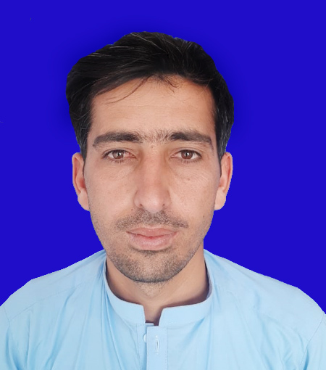

FATHER NAME: Mehrab Khan

DATE OF BIRTH: 12-04-1999

CNIC: 11102-0366047-5

DOMICILE: SD Wazir

RELIGION: Islam

MARITAL STATUS: Unmarried

MOBILE NO: 0336-9755796

E-MAIL: [shafiqwazir345@gmail.com](mailto:shafiqwazir345@gmail.com)

ADDRESS: Isor ghar Killa P/O Domel Tribal areas Bannu

Objective:

I am confident, hard working and reliable person. I compose a friendly disposition with good sense of honor. I can work well under pressure, either as an individual or a part of a team. I am confident that I will be able to fulfill my duties in conformity to the requirements of the organization.

DIT ( MS Office)

BS (Physics)

F.Sc (Pre Engineering)

BTE Peshawar 1023/1400 73.07 2018

UST Bannu 3500/4900 71.42 2022

BISE Bannu 760/1100 69.09 2017

BISE Bannu 834/1100 75.81 2015

Metric (Science)

Certificate/ Level Board / University Marks %age Year

Academic Qualification:

**Experience**

* 06 Months experience in ALSM in CTC form 01-08-2020 to 31-03-2021.
* 13 Months Experience in ALSM at PEOPLE from 01-04-2021 to till date
* 01 Year Experience in Coordinator In State Life from 2019-2020.
* 02 Years experience in a Polio Team Leader area 2 In UC Daryoba.

**Language**

English , Urud , Pashto