C.V

SHAH NAWAZ
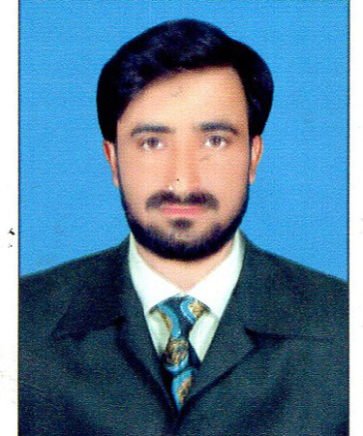

Mailing Address:

Village & P/O Tajaori Moh: Bobo Khel, Tehsil and

District: Lakki Marwat Khyber Pakhtunkhwa.
Mobile number: 0343-9337449

E-Mail shah.03439337449@gmail.com

OBJECTIVE
Being a graduate in Statistics. I have all the potentials and commitment to achieve any task or goal. I have strong communication and analytical skills that is the basic requirement for a graduate to enter in to new Job’s.
NOTE: RECENTLY I WORK AS A COMMUNITY MOBILIZE IN PRIME FOUNDATION LAKKI MARWAT

PERSONAL INFORMATION

- Father’s Name: Rahim Ud Din
- Date of Birth: 02-01-1989
- C.N.I.C #: 11201-8410884-7
- Domicile: Lakki Marwat
- Nationality: Pakistani
- Religion: Islam
- Marital Status: Unmarried
ACADEMIC QUALIFICATION

QUALIFICATION | PASSING YEAR | MARKS / OBTAINED | Division | Board/ University
SSC. (Science) | 2005 | 762/1050 | 1st | BISE Bannu
F.Sc (Pre-Eng) | 2007 | 687/1100 | 1st | BISE Bannu
B.Sc. | 2010 | 366/550 | 1st | U.S.T Bannu
M.Sc. (Ststistics) | 2012 | 1613/2300 | 1st | UST Bannu
Professional Qualifications

QUALIFICATION | PASSING YEAR | MARKS / OBTAINED | Division | Board/ University
C.T | 2014 | 658/900 | 1st | AIOU Islamabad
B.Ed | 2013 | 604/900 | 1st | AIOU Islamabad
PTC | 2010 | 641/900 | 1st | AIOU Islamabad
DIT | 2013 | 1089/1400 | 1st | BTE Peshawar
Hobbies

Football & Painting are my favorite hobbies.
Epxeriences

- Lecturer in Statistics (BPS – 17) out of college Fund in GDC Tajori from 01-02-2012 to 30-04-2013
- Lecturer in Statistics (BPS-17) out of College Fund in GDC Sarai Naurang from 01-09-2013 to 31-10-2014.
- Having two years experience in District Lakki Marwat as Social Mobilizer in POLIO.
- One year experience in MKB Mat Factory Peshawar as Quality checker.
- Two year experience with FAO (UN) for data collection of Food and Agriculture.
- Two Years Experience in SRSP (NGO) Development Program on construction basis.
- Also having experience with BISP as Data Entry Operator.
- 02 years experience as POLIO Worker.
- 01 year experience as TTM under supervisision DHO Lakki Marwat.

PERSONAL PROFILE SKILLS

- Very energetic, Result Oriented and Organized.
- To take the quickly action for every complaint.
- Efficient and well behaved person, suitable for any job.
- Keeping record of the team performance.
- Assisting the office.

MAJOR SKILLS

- Good communication skills.
- Analytical thinking of problem solving.
- Good management skills MS Office.
- Presentation (with/With out slides), Documents preparation/Reports.
- Team Management.

LANGUAGE SKILLS

- Urdu,
- Pashto,
- English.

