Curriculum Vitae
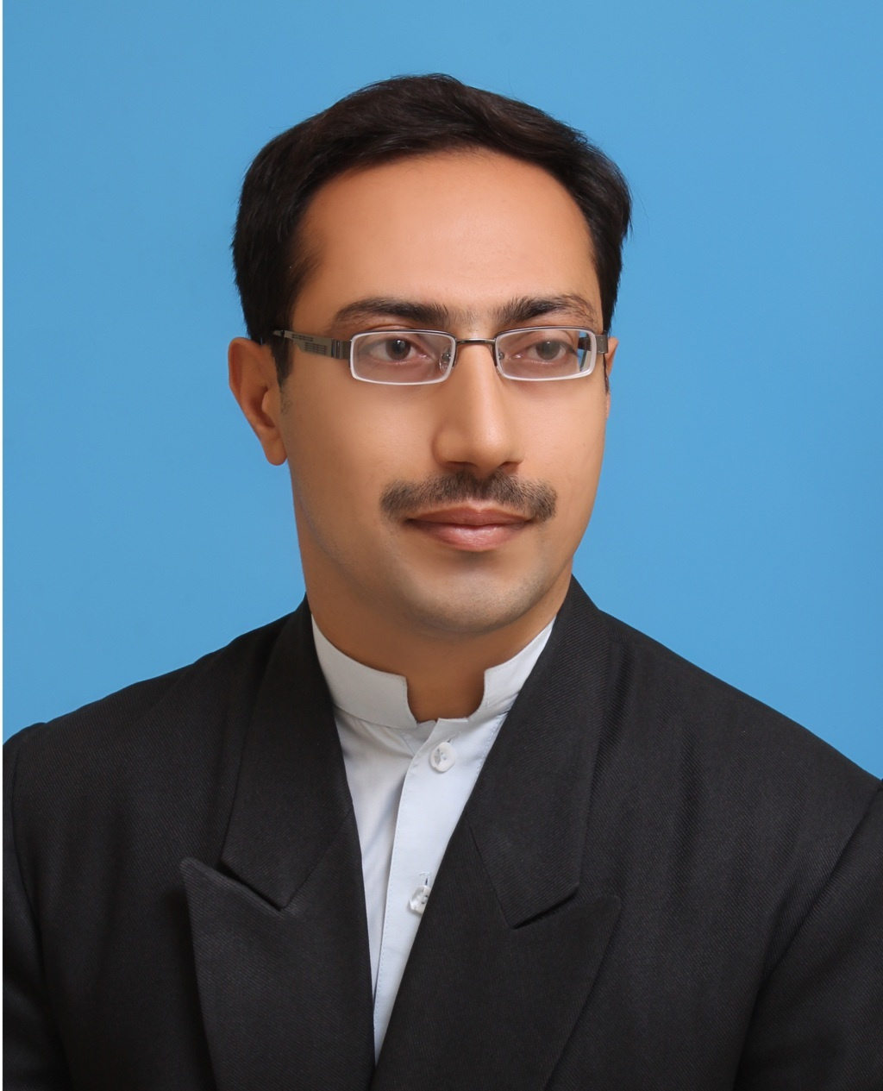

PERSONAL INFORMATION
Name | Sheraz Ahmad
Father’s Name | Fazal Muhammad
Place of Birth | Nowshera
Date of Birth | 01.03.1983
C.NIC. No | 17201-4104285-7
Domicile | Khyber Pakhtunkhwa
Marital Status | Married
Home Address | Flat No.204, Silk Executive Apartments, Board, Peshawar, Khyber Pakhtunkhwa, Pakistan
Contact No. | Mobile No. +92-321-9093226
E-mail Address | sherazahmad99@yahoo.com
Profile | Over 14 years of professional experience and track record of work with Directorate of Education NMTDs (ex-FATA) via UNICEF and GIZ/FDP in EMIS for Public, Private and Deeni Madaris. Contributed to establishment of HRIS for the Education Sector, development and implementation of Education Sector planning process at the DoE and with EMIS. Provided data analysis and support as needed for the process.
ACADEMIC QUALIFICATION
Master |  | MBA from CECOS University Hayatabad, Peshawar completed in 2007.
Graduation |  | B.Sc (Double Maths and Statistics) from Govt. Degree College Pabbi, Nowshera, NWFP in 2003.
Intermediate |  | F.Sc Pre-Engineering from Govt. Degree College Pabbi, Nowshera, NWFP in 2001.
S.S.C |  | Matric (Science) from Govt. High School Pabbi, Nowshera, NWFP in 1999.
PROFESSIONAL QUALIFICATION
Certificate |  | - NGO Management from Institute of Management Studies, University of Peshawar.
Computer skill |  | - EMIS databases (HRIS, ASC, SDSS etc.)  - MS Office 2003, 2007, 2010 & 2013, SPSS  - GIS  - In-page, Adobe Photoshop & Corel Draw  - Hardware/Software installation  - Using Multi Media  - Microsoft Windows  - Internet
JOB EXPERIENCE
Job Title (Current) |  | Database Officer (NF-EMIS) with ALP-PIU (Unicef Funded) Elementary & Secondary Education, Khyber Pakhtunkhwa (from 07.09.2020 till date)
Tasks/Major Area of Working |  | - Determine the primary data and information elements that are required internally and externally to support the project  - Design, develop and manage databases, spreadsheets and other data tools  - Understand, document, and ensure the quality of high-value data for accuracy, consistency and comparability  - Consolidate operational information on a regular schedule to support analysis and design and implement sustainable information management and dissemination systems for data collections  - Develop and implement proper backup, restore, data validation, and security procedures to ensure data integrity and availability  - Propose and implement upgrades to the database webpage, data entry and data storing systems  - Revise the guidelines of using database ensuring clarity and explicitly in terms of using the database and provide visual guidelines  - Contribute new ideas for improving the design and the data engine, quality and timeliness of current issues. Develop ways of communicating messages and transforming it into web based products.  - Act as a focal point/central instrument for the collection, analysis and dissemination of information relevant to the project activities.  - Organize, design and carry out the evaluation and analysis of datasets related to the project,  - Develop data standards and advise on the application of these.  - Participate in the development, implementation and management of new indicators  - Understand, document and ensure the quality of high-value data for accuracy, consistency and comparability
Job Title (Current) |  | Monitoring & Evaluation Officer with KPMD Unit (Unicef Funded) Directorate of Elementary & Secondary Education, Khyber Pakhtunkhwa (from 01.06.2019 31.05.2020)
Tasks/Major Area of Working |  | - Monitor all project activities, and progress towards achieving the project output;  - Develop monitoring and impact indicator for the project success;  - Monitor and evaluate overall progress on achievement of results;  - Monitor the sustainability of the project's results;  - Provide feedback to the Programme Manager on project strategies and activities;  - Suggest strategies to the Programme Manager for improving the efficiency and effectiveness of the project by identifying bottlenecks in completing project activities and developing plans to minimize or eliminate such bottlenecks;  - Collect data from the field, develop and maintain an updated database on indicators/achievements.  - Report monthly, quarterly, and six monthly progress on all project activities to the Programme Manager.  - Provide inputs, information and statistics for the reports on the project.  - Participate in monthly/quarterly project reviews and planning workshops and assist the Project team in preparing relevant reports;  - Support monitoring and evaluation of the effects and impact of the project;  - Assist in coordinating across the available components of the Project to ensure effective implementation of M&E;  - Assist the project personnel with M&E tools and in supporting them in their use.  - Perform other duties as required;
Job Title (3) |  | Data Supervisor (EMIS) with FATA Education Programme (Unicef Funded) Directorate of Education NMTDs (ex-FATA) (from 01.01.2018 31.12.2018)
Tasks/Major Area of Working |  | - Assist the EMIS and M&E sections of DoE NMTDs (ex-FATA) in maintaining online data of EMIS and Developing & Implementation of Real-Time Monitoring System.  - Work as facilitator/moderator for briefing and distribution of Questionnaires to Cluster In-charge/AAEOs.  - Technical assistance for well-functioning education management information systems (EMIS) that is used for improved planning, monitoring, and reporting.  - Report problems, as applicable, in relevant database softwares to the EMIS.  - Run SQL quarries as needed by the EMIS for generation of analytical tables as well as update, maintain existing databases in this regard, and generate various preliminary statistical reports for usage of DoE.  - Provided technical support in conducting 3rd party validation of EMIS data.  - Collaborate with the agency/FR level offices for timely collection and correction of the Annual School Census forms.  - Provide technical support to manage the computer hardware and software related issues of the NMTDs (ex-FATA).  - Modification/Designing/Developing of the Questionnaires of the census of Non-Government Schools, Deeni Madaris & Annual Schools Census (Govt Schools) in guidance of Computer Programmer and collaboration with EMIS cell.  - Assist in updating GIS database for NMTDs EMIS.  - Participate dynamically in dissemination of EMIS outputs as needed.  - Support EMIS section in making ways for appropriate use of EMIS equipment extended to the EMIS NMTDs and support EMIS staff in resolving technical problems.  - Provide support in briefing and distribution of questionnaires to cluster Incharge/AAEOs.  - Conduct general descriptive statistical analyses and other quantitative analyses.  - Support in organizing training, seminars and workshops for EMIS/Policy and Planning Teams as required.  - Assist in Data validation and verification of EMIS.  - Assist the EMIS section in extending support as needed to staff at EMIS FATA in review, analysis and use of data collection instruments for the above mentioned tasks.  - Participate dynamically in dissemination of EMIS outputs as needed.
Job Title (2) |  | Data Analyst (EMIS) with GIZ-FDP, Peshawar. Duty station EMIS Cell Directorate of Education FATA. (from 15.12.2012 to 30.09.2016)
Tasks/Major Area of Working |  | - Data collection & follow-up from Agencies/FRs  - Data entry, editing, cleaning & analyzing the EMIS data to concise and accurate Statistical Reports (Census of Educational Institutes in FATA)  - Work as facilitator/moderator for briefing and distribution of Questionnaires to Cluster In-charge/AAEOs.  - Program support tasks related to EMIS and Human Resource Management Information System(HRMIS)  - Support in organizing training, seminars and workshops for EMIS/Policy and Planning Teams;  - Assist the EMIS section in extending support as needed to staff at EMIS NMTDs in review, analysis and use of data collection instruments for the above mentioned tasks.  - Trouble-shooting as required by the EMIS at the DoE and FDP-Education component.  - Review and compare EMIS Data.  - Checking to ensure verification of EMIS data.  - Compilation and analyzing the collected data.  - Synchronize GIS Database with current ASC 2012-13.  - Analysis of the collected data and comparison with previous census data.  - Correction of schools Nomenclature of FATA.  - Data entry, editing and cleaning.  - Any other tasks assigned by the GIZ and Directorate of Education FATA.
Job Title (1) |  | Worked as a Data Manager cum Analyst under UNICEF Assisted Projects i.e. Project Support Unit, FATA Support Cell & FATA Education Programme from June 2008 to 31.12.2011, based at Directorate of Education, FATA Secretariat, Warsak Road, Peshawar.
Tasks/Major Area of Working |  | - Maintaining and updating quantitative progress of all the project activities funded by UNICEF in FATA.  - Support the EMIS cell in data collection and functions of EMIS.  - Helping the EMIS cell for preparing Annual Statistical Profile.  - Preparing updated reports as per requirements, submission to UNICEF.  - Analyzing field reports on regular basis and preparing summary of gaps in targets.  - Maintaining backup of important data regularly.  - Keeping updated information of progress by other partners in Education such as details of supplies provided, schools rehabilitated, teachers trained, etc.  - Helping field monitors in entering field reports in the computer.  - Developing and maintaining office filing system.  - Fulfilling any other task/s assigned by the Supervisor.  - Arraigning workshops/trainings for the primary schools teachers on parent’s teachers association (Taleemi Islahi Jerga), psycho-social support and meetings etc.
ACHIEVEMENTS
Major Achievements |  | - Completed data cleaning and analysis to support annual education census for public schools private schools and Deeni Madaris  - Supported the DoE with data analysis with regards to target setting in the agency/district level ESPs  - Entered, reviewed and analyzed Human Resource Information System profiles and data. Supervised data entry and cleaning of 24000 public education sector staff  - Analyzed field reports on regular basis and prepared summary of gaps in targets.  - Developed database for details of supplies provided, schools rehabilitated, teachers trained, etc.
Languages |  | Can Speak, Write and Understand English, Urdu and Pashto.

