**SOHAIL UR RAHMAN**

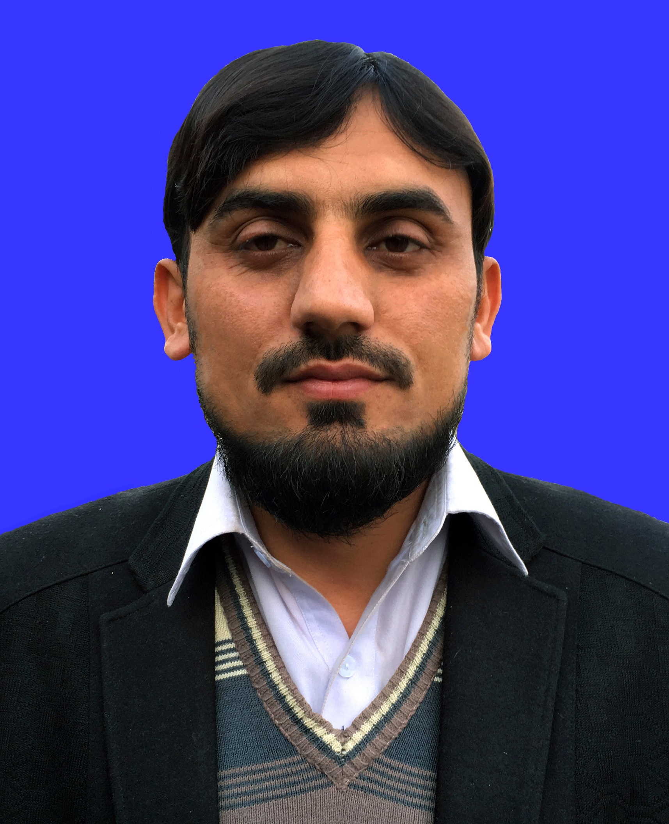

Fazal Haq Malwana Akhundan Surrani Tehsil & District Bannu (KPK), Pakistan.

E-mail: sohail3913@gmail.com

Mobile #: +92-333-4179913/+92-313-4179913

**OBJECTIVE**

I am a confident and enthusiastic person with the ability to learn and adapt quickly to new challenges and to handle difficult situations under pressure. I have an organized approach with good communication skills, which enables me to work effectively either on my own or as a part of the team.

**QUALIFICATION**

|  |  |  |  |  |  |  |
| --- | --- | --- | --- | --- | --- | --- |
| Qualification | Board/University | Year of Passing | Subjects | Marks Obtained | Division/Grade | %age |
| M.Sc | U.S.T Bannu. | 2012 | Economics | 1511/2100 | 1st | 72 |
| B.A | U.S.T Bannu. | 2010 | Eco,Stat | 275/550 | 2nd | 50 |
| F.A | B.I.S.E Bannu | 2007 | Eco,Stat, Math | 701/1100 | 1st | 64 |
| SSC | B.I.S.E Bannu. | 2005 | Science | 600/1050 | 2nd | 57 |

## Technical Qualification

|  |  |  |  |  |  |
| --- | --- | --- | --- | --- | --- |
| S.No | Particular | Marks | Passing Year | Percentage | Board/Institute |
| 1 | DIT | 1239/1700 | 2011 | 73% | Board Of Technical Education KPK |
| 2 | CIT | 240/300 | 2009 | 80% | Trade Testing Board |

## Medical Qualification

|  |  |  |  |  |  |
| --- | --- | --- | --- | --- | --- |
| S.No | Particular | Marks obtained | Total Marks | Percentage | Board/Institute |
| 1 | Medical Technician | 848 | 1450 | 58% | Faculty of Paramedical and Allied Health Sciences ( FPMA ) KPK |

**PROFESSIONAL EXPERIENCE**

**A. Current Job**

**Employer :** World Health Organization, WHO Bannu, Pakistan.

**Position :** Tehsil Polio Officer-Bannu ( TPO Bannu )

**Duration :** Since05 April 2021

**Responsibilities :** Responsibilities were as under:

**A. Current Job**

#### Terms of References Tehsil/Tahluka/Town Polio Officer (TPO)

Under the direct supervision of the Polio Eradication Officer, and the overall technical guidance of the Area Coordinator and Provincial Team Leader, the TPO will undertake the following duties in the assigned Tehsil(s) or Tahluka(s) or Town(s).

# Coordination and Leadership

* + Provide Technical Support to the Tehsil/Tahluka/Town Polio Eradication Committee on poliomyelitis eradication
  + Work closely with government and partners to ensure coordination of different stakeholders in the assigned area
  + Ensure the functioning of the TPEC in the assigned areas
  + Support the full implementation of the National Emergency Action Plan (NEAP) and other key policy documents on polio eradication and immunization at the assigned level.
  + Data evaluation at Tehsil level and support in District level in soft form and in Presentation.

# Supplemental Polio Vaccination Campaigns (SIA)

* Support the TPEC in ensuring the timelines for SIA activities are formulated and followed in the assigned area
* Ensure appropriate selection of appropriate vaccinators and supervisors as per the NEAP guidelines with emphasis on inclusion of females, locals, adult and government accountability of teams and AICs meeting the language and cultural norms of the area.
* Facilitate and monitor the trainings of teams, AICs, and other categories of health workers involved in campaign implementation
* Provide technical support to pre-campaign activities particularly planning, preparing and monitoring the quality of area level Micro-planning, at the union council and tehsil levels.
* Monitor the timeliness and adequacy of all campaign logistics, and ensure all necessary steps are taken to ensure no delays or stock outs of logistics at the assigned areas.
* Monitor the effective utilization of mobile, fixed and transit teams in the assigned areas, and immediately report misuse to the immediate supervisor
* Formulate an appropriate plan for coverage of missed children
* Work closely with the communities in the assigned areas to rebuild trust in vaccines, combat misinformation and generate demand for polio vaccination
* Mobilize religious, tribal and political leaders, and other influential persons in the assigned area to support polio eradication
* Support the TPEC in access negotiations in the assigned areas
* Formulate a daily priority-based supervision and monitoring plans of the AICs and UC teams to ensure support to poor performing areas and motivation of teams.
* Supervise and monitor the work of the teams, AICs and TTMs, take household clusters and at the same time validate a sample of the clusters and missed children coverage done by the UC team
* Ensure all reported missed and poorly covered areas are investigated, and re- vaccination/sweeps carried out.
* Analyze the daily data and collate the observations of the UC teams and present the findings, actions and recommendations at the daily evening meetings
* Provide special focus on the high-risk populations during all the phases of the campaign in line with the special strategies devised for risk populations and the National Emergency Action Plan for Polio Eradication, including supervision of PTPs/TTPs
* Carry out a post campaign analysis of data, review reports, collate, summarize, and disseminate the report to be shared with the authorities in the assigned areas.
* Follow up with respective tehsils/UCMOs in timely filling of DDM cards and submission
* Support vaccine management at the Tehsil level

# AFP Surveillance

* + Under the guidance of the Surveillance Officer or the PEO, support the establishment of community-based AFP Surveillance system in the assigned area
  + Support the Surveillance Officer and PEO in ensuring timely stool/environmental sample collection and transportation as per the SOPs and guidance of the supervisor
  + Conduct regular surveillance visits to assigned areas as per the monthly surveillance work plan
  + Participate in detailed epidemiological investigations as determined by the immediate supervisor
  + Train/sensitize the informal health care givers on AFP surveillance
  + Ensure mapping and inclusion of all formal and informal health care providers in the assigned area in the AFP surveillance network
  + Assist in ensuring inclusion of all high risk/ underserved/ migrant population in the Surveillance network and all AFPs are reported from them.
  + To support timely submission of “Zero Report” from assigned UCs.

# Routine Immunization

* + Support the PEO in strengthening of routine immunization through participation in the development of micro plans for implementation of REC/RED approach
  + Ensure monitoring of EPI coverage and drop-outs
  + Support the TPEC in engaging and mobilizing communities RI demand creation and building the trust of communities in vaccine uptake.
  + Assist the UCMOs in prioritization of UCs that are poorly performing
  + Identify zero dose and under immunized children in the assigned UCs and refer them for immunization.

**B. Previous Job**

**Employer :** World Health Organization, WHO Bannu, Pakistan.

**Position :** UCPO

**Duration :** 15 Jan 2015 to till Date

**Responsibilities :** Responsibilities were as under:

* 100% Micro Planning.
* 100% trained team members above 18Yrs
* Desk Review and Field validation of all micro plans according to standard format and send to PEO/ PDA
* Monitoring and Supervision of AIC and Mobile Teams.
* Collecting Data from respective Health Facilities.
* Supervision of Pre, Intra, and Post Campaign Data.
* Submit DDM Cards to DPCR (Direct Disbursement Mechanism).
* Tally Sheet Analysis.
* Reporting of Zero Dose (routine) and AFP children(s) reported by teams / AIC to UPEC/PEO/PDA.

**C. Previous Job**

**Employer :** World Health Organization, WHO Bannu, Pakistan.

**Position :** TTM

**Duration :** 15th January 2014 to 23 July 2014

**Responsibilities :** Responsibilities were as under:

* 100% Micro Planning.
* 100% trained team members above 18Yrs
* Desk Review and Field validation of all micro plans according to standard format and send to PEO/ PDA
* Monitoring and Supervision of AIC and Mobile Teams.
* Collecting Data from respective Health Facilities.
* Supervision of Pre, Intra, and Post Campaign Data.
* Submit DDM Cards to DPCR (Direct Disbursement Mechanism).
* Tally Sheet Analysis.
* Reporting of Zero Dose (routine) and AFP children(s) reported by teams / AIC to UPEC/PEO/PDA.

**D. Previous Job**

**Employer :** DHO Office, Bannu, Pakistan.

**Position :** DPMT

**Duration :** 1stAugust 2014 to 14 Jan 2015

**Responsibilities :** Responsibilities were as under:

* 100% Micro Planning.
* 100% trained team members above 18Yrs.
* Desk Review and Field validation of all micro plans according to standard format and send to PEO/ PDA.
* Monitoring and Supervision of AIC and Mobile Teams.
* Collecting Data from respective Health Facilities.
* Supervision of Pre, Intra, and Post Campaign Data.
* Submit DDM Cards to DPCR (Direct Disbursement Mechanism).
* Tally Sheet Analysis.
* Reporting of Zero Dose (routine) and AFP children(s) reported by teams / AIC to UPEC/PEO/PDA

**E. Previous Job**

**Employer :** Allama Iqbal Model High School Turka Bazar, Bannu, Pakistan.

**Position :** Teacher

**Duration :** 1st Jan 2012 to December 2013

**Responsibilities :** Responsibilities were as under:

* Teaching of different subjects.
* Improve Knowledge of children.
* Administration.
* Improve Standard of Living of children.

**PROFFISSIONAL COURSES/TRAININGS**

|  |  |  |  |  |  |
| --- | --- | --- | --- | --- | --- |
| **Qualification** | **Board/University** | **Year of Passing** | **Marks Obtained** | **Division/Grade** | **%age** |
| P.T.C | A.I.O.U Islamabad | 2015 | 650/900 | 1st | 72% |
| C.T | A.I.O.U Islamabad | 2016 | 642/900 | 1st | 71% |
| B.Ed | A.I.O.U Islamabad | 2012 | 630/900 | 1st | 70% |
| M.Ed | Sarhad University Islamabad | 2016 | 861/1200 | 1st | 72% |

**PERSONAL INFORMATION**

* Name: Sohail Ur Rahman
* Father’s Name: Niaz Ur Rahman
* NIC: 11101-5589952-5
* Date of Birth: 03-04-1989
* Domicile: Bannu (KPK)
* Postal Address: Fazal Haq Malwana Akhundan P/O Surrani Bannu: Tehsil & District, Bannu (KPK), Pakistan.
* Marital Status: Married
* Nationality: Pakistan
* Religion: Islam
* Linguistic Skills: Proficient in English, Urdu and Pashto.

**REFERENCE**

1: **(Dr.Alam Zeb Area-Co-Coordinator Bannu Division)** **Surveillance of Polio Eradication Officer** Bannu Mob: 03339722880. E.Mail: az_khan945@yahoo.com

2: **(Mr.Shahid Jamshid Programmer Data Assistant )** **WHO**-Bannu Division

Mob: 03339724021. E.Mail: pdabannudiv@gmail.com

3: **( Dr.Arsalan Khan PEO Bannu ) Polio Eradication Officer**-Bannu Mob: 03469293754 E.Mail: khan3095@gmail.com

4: **( Dr.Mehtab Khan PEO Bannu ) Polio Eradication Officer**-Bannu Mob: 3088088801 E.Mail: [dr.mehtabkhan1122@gmail.com](mailto:dr.mehtabkhan1122@gmail.com)

5: **( Dr Sultan Ahmad DSO Bannu ) Diseases Surveillance Officer WHO-** Bannu Mob: 0301-8966790 E.Mail: [ahmadsu@who.int](mailto:ahmadsu@who.int)

6: **( Dr. Farman Ullah IO-WHO Bannu ) Immunization Officer**-Bannu Mob: 03339726971

E.Mail: [fkhan@who.int](mailto:fkhan@who.int)

7: **( Dr Naeem Khan AC-WHO Bannu ) Area Coordinator**-Bannu Division Mob: 03339412037 E.Mail: [wazin@who.int](mailto:wazin@who.int)

8: **( Dr.Illaudin NPO National Professional ) Officer** **WHO-PEOC** Mob: 0333-3975552

Email: [sowho_tk@hotmail.com](mailto:sowho_tk@hotmail.com)

9: **(Dr. Khwaja Irfan AC-Sawat) Area Coordinator WHO** Mob: 0333-9343244, Email: [irfanshahzad@hotmail.com](mailto:irfanshahzad@hotmail.com)

10: **( Dr Farman Ullah IO-Bannu ) Immunization Officer WHO-**Bannu Mob: 0333-9726971, Email: [fkhan@who.int](mailto:fkhan@who.int)

11: **( Dr.Imran NSTOP Officer ) District Bannu** Mob: 0336-5935392

Email: nstopbannu@gmail.com