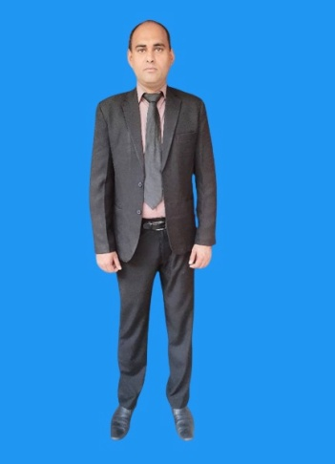

**SYED RIZWAN ALI ZAIDI**

**Qualification**

**B.Sc (Bachelor of Science, Double Mathematics and Physics)**

**F.Sc (Pre-Engineering Group)**

**Matriculation (Science Group)**

**Telecommunication course “Line & Mobile” Technology**

**I.T Course (Ms Office, Internet Explorer, Social Media Apps)**

**Skills**

**Accounts, Business, Inventory, Sales, Purchase, Manufacturing, Customer Dealing, Hospitality Industry**

**Professional Experience**

**(1)Technical & Business Experience:**

**I am working in my small business of manufacturing and sales for many years. I always remain very sincere with every customer and I always deal to every customer with nice attitude and best behavior. I am manufacturing & selling Transformers, U.P.S (Uninterrupted Power Supply), Voltage control stabilizers, D.C batteries charging transformers, D.C pump chargers and 110 volts transformers. I can also install solar panels in series and parallel order. I started working on 8th October 2007 and still I am working alone in my small technical business of sales and manufacturing.**

**(2)Accounts Experience:**

**I was working and learning online about payroll (accounts) in “Legend Financial” company in London (U.K). I was working and learning online in “Bright Pay” payroll software. I was working in RDP (Remote Desktop Protocol). I was using Microsoft Teams, MS Outlook, MS Word and MS Excel. I always want to learn new innovative skills and techniques. I worked and learnt online from 16-01-2023 to 08-05-2023.**

**(3)Inventory Experience:**

**I have worked as an inventory coordinator in accounts department of Holiday Inn Hotel Islamabad (New name is Islamabad Hotel). I used to receive fresh chicken, fresh fruits, fresh vegetables, mutton, beef, grocery items, general store items, hardware items, ice cream and confectionery. The assistant supervisor and workers also used to count all the crockery, small and big machines of the hotel under my supervision. I also used to make the bills of all the items. I also used to issue all these items to the hotel staff. I worked from 24-11-2005 to 01-06-2006.**

**Personal Information**

**Mobile Numbers: +923345089805 & +923166837202**

**WhatsApp Number: +923345089805**

**Business WhatsApp: +923166837202**

**Permanent Address: House# 514, Ward# 1, Street Jahan Shah Layyah. Pakistan**

**E-mail Addresses: rizwanalizaidi1983@gmail.com & rizwanalizaidi@yahoo.com**

**Passport Number: DM5972043**

**Date of Birth: 03-04-1983**

**Marital Status: Married**

**Corona Vaccination: Completely Vaccinated**

**Languages**

**(1) English is my favorite language. I can read, write, speak and listen English very well. (2) Urdu is my native language. I can read, write, speak and listen Urdu very well.**

**Hobbies**

**Cooking, Music, Movies, Fishing, Gym**