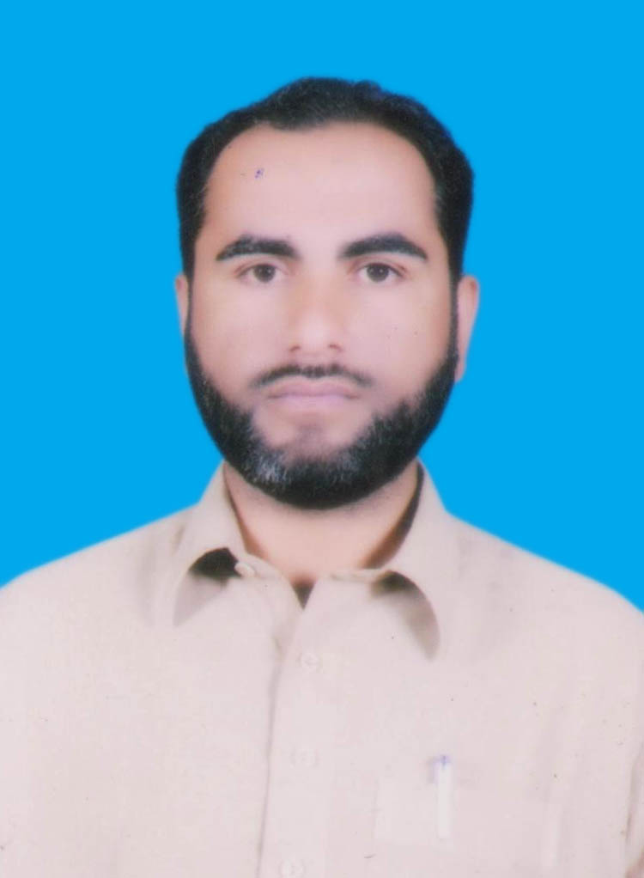

Tahir Muhammad

Mailing Address: village Lala Ziarat Tehsil and PO MAKEEN
Permanent Address:
Village & Post Office, Tehsil Makin, Dist SW TD.
Mob 0344-9322104, 0304-0655922 | Email: tahirmehsood84@gmail.com

Objective:

To work within competitive environment, so that I can explore my hidden professional capabilities for the best interest of the organization.

Personal Information

- Fathers Name : Sher Muhammad
- Date of Birth : 1st June, 1984
- C.N.I.C # : 21703-0636522-7
- Gender :Male
- Domicile : SW TD.
- Nationality : Pakistani
- Religion : Islam
- Marital Status : Married

Academic Qualification:

DEGREES | YEAR | Marks | BOARD / UNIVERSITY
S.S.C (Science) | 2000 | 609/850 | BISE Bannu
F.Sc (Pre-Medical) | 2004 | 757/1100 | BISE Bannu
B.Sc (Biological Sciences) | 2005 | 316/550 | Gomal University DIKhan
M.Sc (Botany) | 2007 | 1341/2050 | Gomal University DIKhan

Profehinoal Qualification:

DEGREES | YEAR | Marks | BOARD / UNIVERSITY
B.Ed | 2008 | 584/900 | AIOU Islamabad.
M.Ed | 2013 | 737/1200 | AIOU Islamabad.

Expereince:
- 2 Year Exp: as Campaign support Person at Teh:MAKEEN 2007-2009
- 1 Year NIP Internee 2009 To 2010.
- 6 Months at Qurtaba College D.I.Khan 2010 2011.
- 3 Months as Lecturer at GDC No.3 D.I.Khan2011-2011.
- 6 Months at Waziristan S/College D.IKhan 2012.
- 4 Year as Principal At AQ Khan School Pusha Pul D.I.Khan.

- 4.5 Years Experience as (UCPO) Union Council Polio Officer (WHO) at Tehsil Makin, UC Wadan, SWTD(15 November 2016-4th April 2021)
- 3 Years Experience as Tehsil Polio Officer at Tehsil Makeen SW-UPPER (5th April till date)

Skills:
- Teaching,Communication, Public Dealing, Data Analysis, Monitoring & Supervision.

Language Skills:

- English, Urdu, Pashto,

References:
- Mr. Umar Dil Khan (PEO) WHO Mob: 0334-9066003:3009066003
- Mr. Dr.Asad Baig(AC)WHO Mob:03356159265,03492393356
- Dr.Asmat Ullah District Coordinator WHO(+92 344 8222956)
- Dr.Naveed Immunization officer WHO(+923429499949)

