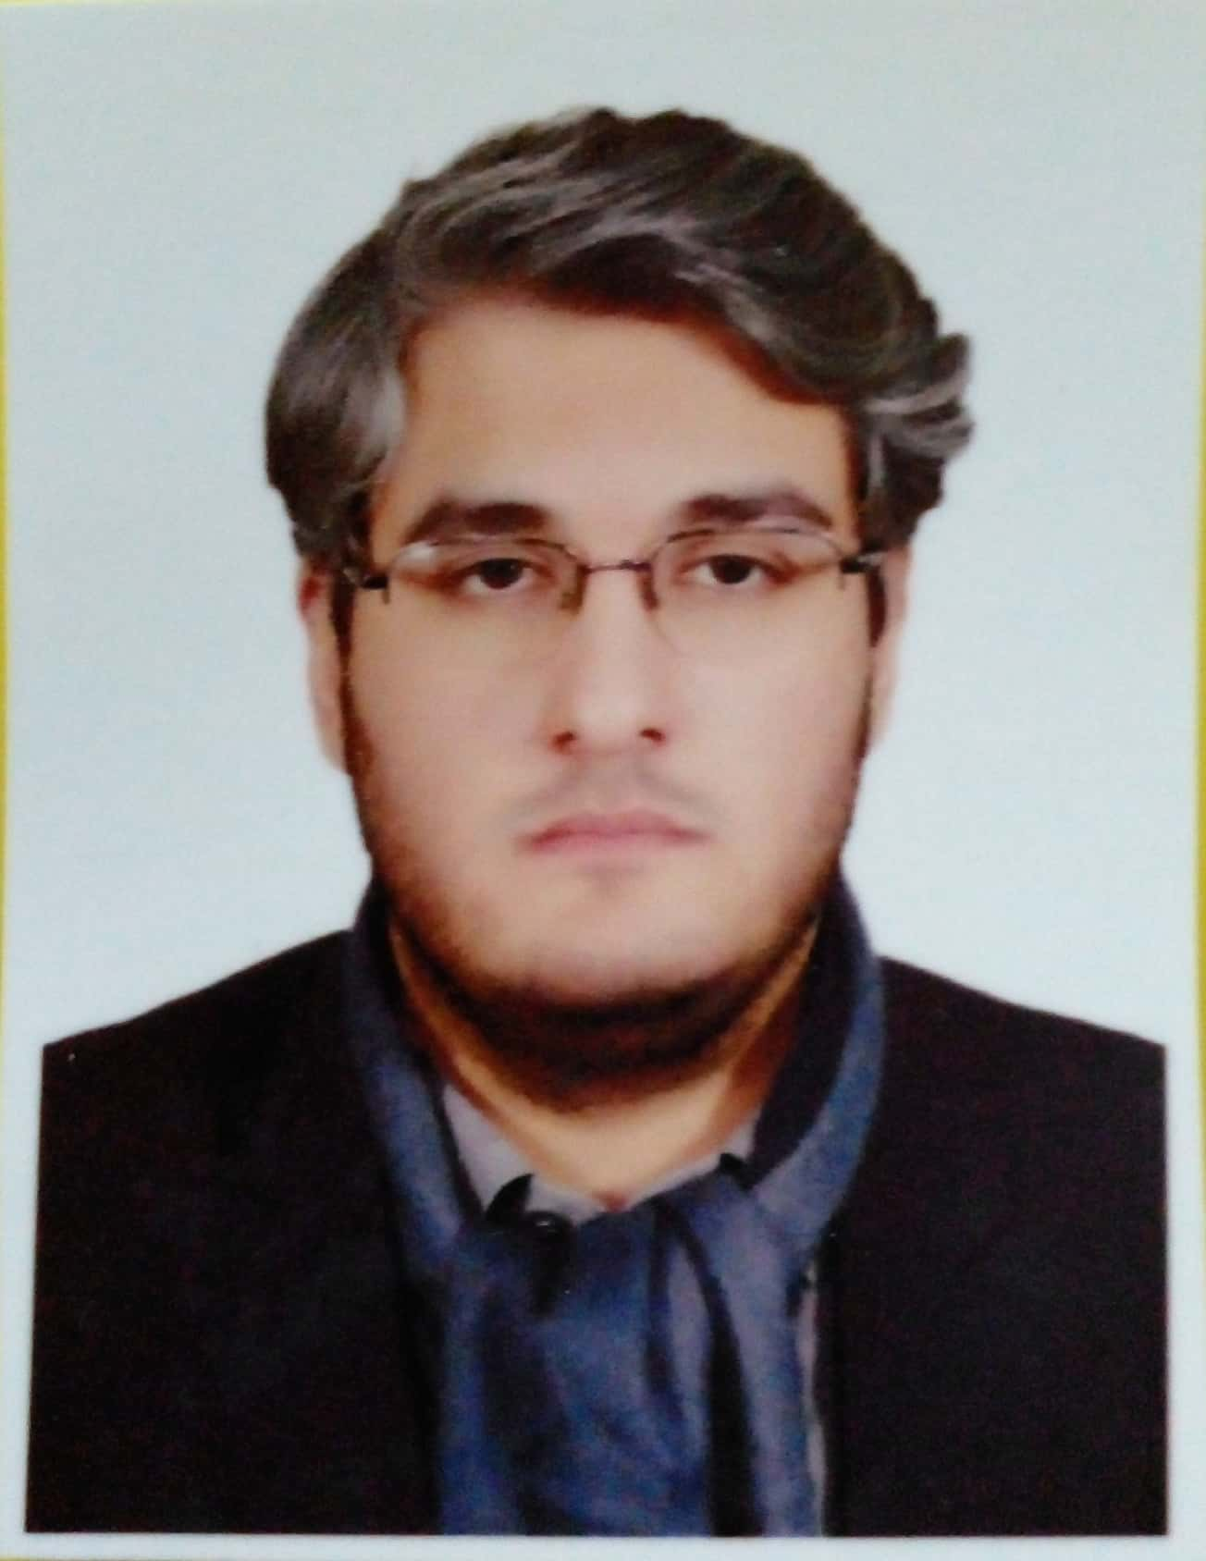 |  | Tanweer Ali Khan  Doctor
Profile  Medical graduate, Public Health Scholar. Infection Prevention and Control Expert. Experienced in medical diagnosis, management & interpretation. Multilingual and well versed in Pushto, Urdu and English languages  Contact  PHONE:  0336 998 8508  EMAIL:  khantanweer61@gmail.com  Hobbies  Literature  Linguistics  Teaching  Gardening  Eschatology |  | EDUCATION  Masters in Public Health (4 Semester)  Certified in Infection Prevention and Control, IPC from WHO  2023  Certified in Health Professional Education, CHPE from Peshawar Medical College  2023  Certificate in PBL preparation and delivery  2023  MBBS from Peshawar Medical College  2015 - 2020  F.Sc Pre-Medical from Islamia College Peshawar  2012 - 2014  Matriculation from Peshawar Model School  2012  WORK EXPERIENCE  Demonstrator in Community Health Sciences Peshawar Medical College (currently)  General Secretary IPC PRIME group of Hospitals. (currently)  Medical officer in North West General hospital (2022)  Kuwait Teaching Hospital as House Officer  Jan’2021–June’ 2021  6 months as house officer in Surgery and allied  Mercy Teaching Hospital as House Officer  July’ 2021–December’2021  6 months as a house officer in Medicine and allied

