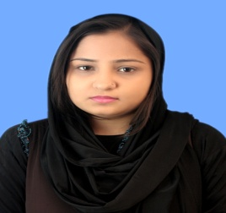

**TAYYABA TANVIR**

CONTACT **E-mail**: [tayyaba.salman28@gmail.com](mailto:tayyaba.salman28@gmail.com) **Phone**: +92 3446876591

**OBJECTIVE** I am a skilled person, proficient in performing duties efficiently and well. I am an energetic and discipline person with a good academic background. I am looking for a job where I can develop my skills more.

**EDUCATION**  **Bachelor of Business Administrative** **2013 — 2017**

Iqra University

**Intermediate 2010 — 2012**

Science and Commerce collage for girls

**Matriculation 2008 — 2010**

H.N.Public Secondary School

**PERSONAL INFORMATION**

* + **Father’s Name**: Tanvir Khalid
  + **Date of Birth**: Aug, 15, 1993
  + **Nationality**: Pakistani
  + **Religion**: Islam
  + **Gender**: Female

WORK EXPERIENCE

* 2 months experience as a CSE in TRG

PROJECTS

* Did research on “Relationship between self-esteem, transformational leadership and innovative success: A case of telecom sector in Pakistan”
* Research failed product and Re launch (OLFRUTE JUICES)
* Identify key problems: work-family conflict, and the job-life satisfaction relationship: a review and directions for organizational behavior-human resources research

SKILLS

* Ability to learn new skills quickly and accurately
* Committed and dedicated towards my work.
* Ability to work effectively in a team
* A good time management skills
* Research skills
* Self-motivate

COMPUTER SKILLS

* Microsoft Office (Ms. Word, Ms. Power-point, Ms. Excel, Ms. Publisher)

INTERESTS

* Listening music
* Traveling
* Internet surfing
* Watching television
* socializing with friends

Reference

Available Upon request

s