CURRICULUM
VITAE
RESUME
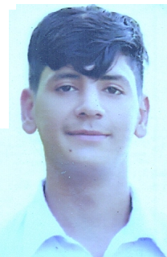
Name: Ubaid Ullah Khan
Email: ubaidullah6121@gmail.com
Father’s Name: Noor Hussain
Date of Birth: 14-01-2004
CNIC: 15604-0433763-1
Gender: Male
Domicile: Swat
Marital Status: Single
Nationality: Pakistani
Religion: Islam
Cell No: +923449506121
+923245330759
Address: Dehrai Kabal Sawt.
OBJECTIVE:
To join a well reputed organization that offers opportunities for the personal growth and career development where I will be a productive member of the organization/institution and where I could enhance my capabilities.

ACADEMIC/PROFESSIONAL QUALIFICATION:

CERTIFICATE/ DEGREE | Passing Year | Marks | BOARD/UNIVERSITY
S.S.C (Science) | 2019 | 858/1100 | Bise Swat
FSC | 2021 | 660/1100 | Bise Swat
Surgical Diploma | 2022 | 890/1450 | Faculty Peshawar
WORKING EXPERIENCE:
• 6 months experience as a Health Surgical in Saidu Teaching Hospital.
•1 year experience as a Health Surgical in Habiba medical center Swat.

Safety Curses :
IOSH, OSHA

LANGUAGES:
, Urdu, Pashto.English

INTEREST & HOBBIES:
- Reading Books/News, Internet Surfing,

